

Skills Organisation Pilots Evaluation

Project 1 – Implementation Review Report

Prepared for the Australian Government

**Department of Education, Skills and Employment**

February 2022

|  |  |
| --- | --- |
| URBIS AND ARTD STAFF RESPONSIBLE FOR THIS REPORT | |
| Director | Julian Thomas, Andrew Hawkins |
| Associate Director | Sidonie Roberts, Christina Bagot |
| Manager | Steve Yeong |
| Consultants | Greta Newman, Abbey Wiseman, Jayde Grisdale |
| Project Code | P0025272 |

**This document was collaboratively produced by Urbis and ARTD.**

Contents

[Executive Summary 1](https://urbisau.sharepoint.com/sites/EvaluationofSOPs/Collaboration/Reporting/Project%201%20Report/06%20Publication%20ready%20versions/Evaluation%20of%20the%20SO%20Pilots%20-%20Project%201%20Final%20Report%20.docx#_Toc96414857)

[1. Introduction 6](https://urbisau.sharepoint.com/sites/EvaluationofSOPs/Collaboration/Reporting/Project%201%20Report/06%20Publication%20ready%20versions/Evaluation%20of%20the%20SO%20Pilots%20-%20Project%201%20Final%20Report%20.docx#_Toc96414858)

1.1. Context 7

1.2. Our approach 10

[2. Current state 14](https://urbisau.sharepoint.com/sites/EvaluationofSOPs/Collaboration/Reporting/Project%201%20Report/06%20Publication%20ready%20versions/Evaluation%20of%20the%20SO%20Pilots%20-%20Project%201%20Final%20Report%20.docx#_Toc96414861)

2.1 Human services 15

2.2 Digital 20

2.3 Mining 24

[3. Implementation learnings 28](https://urbisau.sharepoint.com/sites/EvaluationofSOPs/Collaboration/Reporting/Project%201%20Report/06%20Publication%20ready%20versions/Evaluation%20of%20the%20SO%20Pilots%20-%20Project%201%20Final%20Report%20.docx#_Toc96414865)

3.1 The authorising environment 29

3.2 Engaging stakeholders 33

3.3 Establishing core capabilities 37

3.4 Deciding priorities and projects 41

3.5 Delivering on workplans 45

Appendix A: Evaluation Framework 47

Appendix B: Stakeholders consulted 49

Appendix C: References cited 53

**Acronyms**

| **Acronym** | **Meaning** |
| --- | --- |
| ACWIC | Aged Care Workforce Industry Council |
| DESE | Australian Government Department of Education, Skills and Employment |
| DSDM | Digital Skills Development Model |
| CEO | Chief Executive Officer |
| Digital SO | Digital Skills Organisation |
| ECEC | Early childhood education and care |
| FTE | Full Time Equivalent |
| GDP | Gross Domestic Product |
| Human Services SO | Human Services Skills Organisation |
| ICT | Information and communications technology |
| IRC | Industry Reference Committee |
| MCA | Minerals Council of Australia |
| METS | Mining Equipment, Technology and Services |
| Mining SO | Mining Skills Organisation |
| NCVER | National Centre for Vocational Education Research |
| OECD | Organisation for Economic Co-operation and Development |
| RTO | Registered Training Organisation |
| SO | Skills Organisation |
| SSO | Skills Service Organisation |
| TAFE | Technical and further education |
| TOR | Terms of reference |
| VET | Vocational Education and Training |

**This document was collaboratively produced by Urbis and ARTD.**



# Executive Summary

### Context

As part of the 2019-2020 Federal Budget, the Australian Government announced the $585 million Skills Package – *Delivering Skills for Today and Tomorrow* (Skills Package). The Skills Package included the establishment of the Skills Organisation (SO) Pilot program to trial new ways of working to shape the national training system to be more responsive to the skills needs of employers.[1]

Under the program, SOs have been established in three priority industries – human services, digital and mining. The scope of work for the SOs is flexible to suit different industry contexts, and includes identifying skills needs, developing qualifications and improving the quality of training delivery and assessment.

In the 2021-22 Federal Budget, the Australian Government announced new industry engagement arrangements to strengthen the role of industry in the Vocational Education and Training (VET) system. An additional $149.2 million (bringing the total investment up to $292.5 million) has been allocated over four years to establish new Industry Clusters to provide industry with a stronger, more strategic voice and broader role to drive reforms to Australia’s VET system, to ensure it delivers on employer and learner needs. Initial lessons learnt from the SO Pilots have informed the development of these reforms.

The Australian Government Department of Education, Skills and Employment (DESE) has commissioned Urbis/ARTD to undertake an evaluation of the SO Pilots, which includes an implementation review and a meta-evaluation of early project impacts. This report presents findings from the first phase of the evaluation (Project 1), which has focused on the implementation review.

### Evaluation goals

This evaluation focuses on four key areas of inquiry:

1. effectiveness and timeliness of DESE’s approach to standing up the three SO Pilots in context of the SO Pilot program’s objectives
2. an analysis of current capacity and performance from each SO Pilot’s perspective and timeframes for each SO Pilot to be fully operational
3. early impact of the SO Pilots’ engagement with industry
4. opportunities to improve the speed and effectiveness of establishing new SO Pilots, or similar organisations, in future.

### Our approach

The evaluation is being delivered over three phases:

* ‘Project inception, mobilisation and planning’ involved setting up and planning for the evaluation.
* ‘Project 1’ (this report) focused on gathering insights on the establishment and implementation of the SO Pilots.
* ‘Project 2’ will explore early outcomes, including in relation to the program-level impact of the SO Pilot model and achievement of policy objectives.

Our evaluation methodology for Project 1 included the collection and analysis of both primary and secondary data. This report is informed by the following data sources:

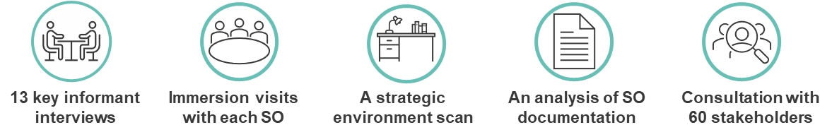

### Overall findings

This first evaluation report (Project 1) partly addresses the four evaluation goals, with further data collection and analysis to inform the final report (Project 2).

**Effectiveness and timeliness of DESE’s approach**

* DESE’s flexibility, collaborative approach and practical and technical assistance effectively enabled the SOs to establish employer-led models with a high degree of strategic autonomy. Notwithstanding the fact the SO Pilot program was established to inform the broader VET reform agenda, we found that earlier and clearer definition of the role and long-term goals of the SOs would have provided greater strategic clarity to support a faster start.

**Current capacity and performance**

* SOs are currently operating with small, agile teams, who work with sub-contractors and through partnership arrangements to deliver their work programs. Establishment trajectories vary significantly, with progress to date largely influenced by the degree of industry consensus on key issues and probable solutions, and the extent to which SOs have established the requisite formal and informal authority to act.

**Early impact of the SO Pilots’ engagement with industry**

* Industry structure and strategic environment vary greatly between SOs, and this shaped their engagement strategies during the establishment phase. Project 2 will further explore the early impacts of industry engagement for each SO.

**Opportunities to improve the speed and effectiveness of establishing new SOs**

* Several observations can be made about factors that may improve the speed and effectiveness of establishing new SOs, including the importance of establishing a clear authorising environment, engaging early and strategically with stakeholders, investing in early creation of core capabilities within the organisation, determining work priorities and delivering on workplans.

These observations are discussed further below.

### The authorising environment

The Joyce Review recommended that SOs be industry-led and assume a leadership function in support of a VET system that better meets the needs of employers, the economy and learners. SOs were established to “operate as employer-led organisations with genuine, transparent and broad representation and support across their industries”.[2] We found that:

* DESE’s supportive approach, which provided flexibility for SOs to operate with a degree of strategic autonomy within the framework established by the program guidelines, lent credibility to their identity as employer-led.
* Establishing employer-led steering groups and subsequently SO boards helped establish SOs’ credibility and authority within their sectors and with other industry stakeholders.
* Each SO has needed to manage how their remit crosses over with policy activity or initiatives driven by different government portfolio areas, although the degree of practical impact varies.
* Establishing the SOs as pilots without confirming the next stage of reforms (since resolved with the 2021 Budget announcements) created some sector confusion and challenged relationships with some elements of the existing system.
* Each of the SOs showcases a different way to define the industry from which they require both formal and informal authority to operate effectively.

### Engaging stakeholders

Each SO Pilot was tasked with leading industry engagement in the VET sector, strengthening “sector networks and feedback loops” and working with the national VET governance structures to influence changes that will improve VET for their industries.[3] The program guidelines also specifically signal the need to secure industry support for governance arrangements and both industry and VET sector agreement for proposed activities.[4] Our observations of the SO Pilot experience to date include:

* The broad-based, ‘whole of economy’ nature of digital skills required a different engagement approach to sectors defined more clearly by employer activity (mining and human services).
* The strategic environment impacts stakeholder attention; for example, the human services sector has been significantly impacted by COVID-19, and by contributing and responding to two Royal Commissions.
* The Mining SO’s origin in an established, well known and credible organisation supported earlier stakeholder engagement, while the Human Services SO and Digital SO required investment in organisation building before broader stakeholder engagement could commence.
* The Mining SO was able to effectively leverage Minerals Council of Australia (MCA) stakeholder networks to support engagement from outset. However, the Human Services SO and Digital SO are taking more time to build consistency in communicating their strategy to their broader stakeholder networks.
* Stakeholder uncertainty about the longer-term role of SOs, and concerns about the changing balance of influence from those with vested interests, have been inhibitors to SO engagement.
* The diverse experiences of the SOs demonstrate how a cohesive or fragmented industry will shape industry engagement strategies.

### Establishing core capabilities

SO Pilots were tasked to operate as with the necessary corporate infrastructure and governance arrangements to be able to undertake the range of projects, sector engagement, and advisory functions set out in the program guidelines. Each SO Pilot has followed a different pathway to organisational maturity. Some of the general observations that emerge from the establishment period include:

* Recruitment of the CEO position is an inflection point that significantly accelerates organisational establishment and capability development.
* SO boards and their appointed CEOs are well networked with employers, but have fewer in-built linkages with the VET system; executive team appointments with specialist expertise in the VET system was a substantial boost to each organisation’s core capability.
* SO Pilots benefited from receiving practical and technical support for the incorporation and early establishment period. This was primarily provided by DESE or contracted services, but in some cases pro bono by board members’ organisations.
* The three SOs have built a degree of rapport and have regular points of contact, including sharing documentation, insights and experience. These relationships are valued by SO staff.

### Deciding priorities and projects

The program guidelines set the strategic framework for the SO Pilot program and provide details on the scope of program activities, funding arrangements and expected outcomes. The guidelines state that activities must “align with the Skills Pipeline and demonstrate a clear benefit to the national training system and its end users”.[5] SO Pilots are also tasked with undertaking activities that were consistent with the SO Pilot Principles [6] (these are also listed on page 10).

In examining SO Pilots’ responses to their mandate, we observed that:

* Consistent with the intent set out in the SO Pilot program guidelines, the SOs express strategic aspirations for their influence on the VET landscape which extends beyond the generally shorter-term goals of their project activities.
* SOs’ workplans encompass strategic research and knowledge transfer, stakeholder engagement and facilitation, and applied projects focused on pathways, qualification or specific skillsets.
* SOs have taken different approaches to work planning. The Human Services SO has invested more heavily in mapping their sector’s activity than the Digital SO, which has prioritised moving rapidly to project delivery. The latter approach carries some risks of duplicating efforts. The Mining SO has an identified focused on practical project outcomes.
* Some stakeholders within and outside of government have voiced some concerns about the work program transparency, and alignment to broader reforms within the VET sector.
* The experiences of each SO indicate that the pace of progress will be influenced by the extent to which there is industry consensus on key issues and probable solutions.

### Delivering on workplans

As at August 2021, SO Pilots are all still in the relatively early stages of implementing workplans. While the next evaluation phase (Project 2) will examine workplan output in more depth, we note that:

* SOs remain relatively small, allowing them to leverage partnerships and contracting arrangements to deliver much of their work program.
* Pilot projects are mainly being delivered with third parties because the SOs recognise the skillsets and capabilities that others can bring, and the diversity of projects.
* SOs’ internal culture, language and methodologies align to the industries they represent. Cultural alignment in this way is likely to strengthen SO credibility as employer-led entities.



# Introduction

## Context

### The skills pipeline

While the Australian economy has experienced close to three decades of economic growth,[7] new challenges and opportunities have emerged in response to increasing globalisation, shifting demographics, technological advancement, and the economic shock of COVID-19.[8] These include:

* **Digital transformation:** The Organisation for Economic Co-operation and Development (OECD) forecasts that in the coming decades, 14 per cent of jobs are at risk of automation and 32 per cent are likely to be impacted by significant change and modification.[9]
* **Increase in non-routine jobs as a share of total employment:** Research emphasises the growing importance of non-technical skills, including creative and analytical thinking and innovative and complex problem-solving.[10]
* **Ageing population:** As Australia’s population ages, labour shortages are emerging, for example demand for care workers is growing year on year.[11]

As the structure of Australia’s labour market continues to shift towards knowledge and innovation-driven industry, the VET system will play a critical role in ensuring the Australian workforce can develop the workplace and industry-specific skills they need to perform the jobs of the future.[12]

The VET system can be conceptualised as a five-stage skills pipeline that seeks to deliver skills that are current, responsive and relevant to employers and the economy more broadly (see Figure 1). The VET skills pipeline outlines the key components of the skills development process, beginning with the forecasting and identification of skills through to the timely supply of skilled labour.[13]

Figure 1 – The VET skills pipeline

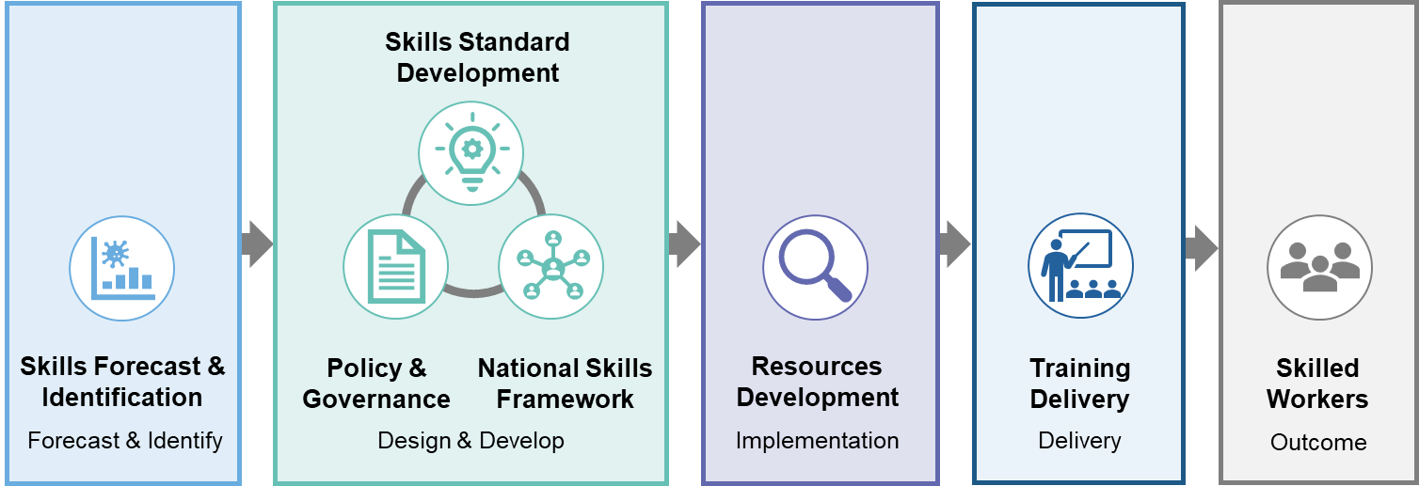

Source: Adapted from DESE (2021), Guidelines for Skills Organisation Pilots

### The Joyce Review

An independent review of Australia’s VET system was undertaken in 2018. The review, *Strengthening Skills: Expert Review of Australia’s Vocational Education and Training System* (the Joyce Review), identified two challenges for Australia’s VET system. First, that employers often have difficulty finding people with the right skills to meet their business needs; and second, that employers should be more involved in shaping the VET system in future.[14]

In response to the recommendations from the Joyce Review, the Australian Government announced its commitment to strengthening the VET system through a $585.3 million funding package. The funding package was called *Delivering Skills for Today and Tomorrow* (Skills Package) and commenced under the 2019-20 Budget.[15] The Skills Package aims to ensure the VET system can provide a timely flow of skilled workers to meet industry needs. Importantly, the package lays the foundation for the reforms set out in the Joyce Review by supporting the exploration of new ways of placing industry at the centre of the skills system and raising the profile of the VET sector across industry.[16]

As part of the package, the Australian Government committed to piloting SOs in two industries – human services and digital technologies. In late 2019, the mining sector was added to the initiative.

The goal of the SO pilot program is to trial new ways of working to shape the VET system to be more responsive to skills needs across the skills pipeline, including:

* identification of skills needs
* qualifications development
* improved quality of training delivery and assessment.

Lessons learnt from the Pilots, together with information gained through stakeholder consultations, have helped inform broader improvements to the national VET system.

### Co-design and consultation

DESE undertook national co-design consultations from September to December 2019 to inform the development of the SO Pilots. The co-design process was informed by a discussion paper and included a submissions process and a series of workshops and roundtables.[17] Consultations sought stakeholder views on the challenges for the VET system in terms of responsiveness, relevance and promoting quality, as well as opportunities for system improvements that SOs could deliver.[18]

In total, 40 separate submissions were received with more than 500 stakeholders taking part in the consultations. The consultations included two employer roundtables, 35 interviews and 13 workshops in all capital cities as well as in Bendigo, Orange, Cairns, Mt Isa and Karratha. Stakeholders consulted included education providers, employment/career providers, employers, state and territory governments, and peak bodies.[19]

A report by DESE summarising the co-design consultations confirmed there was a broad view across the different stakeholder groups that participated in these consultations that now was the time to identify and address the current gaps in the VET system and better harness the opportunities of an industry driven approach.

The report identified two major opportunities for system improvements.[20] First, that SOs could contribute to the creation of a modern, high quality VET system; and second, that VET could become more industry relevant. The report also identified the following challenges facing the training system:

* slow speed to market reduces relevance of training
* training does not meet industry needs
* inflexibility and complexity inhibit training quality.[21]

The establishment of steering committees and associated working groups for each SO sector were also key to supporting early industry engagement with program design. These provided a forum for collaborative development of the SO models in a way that was highly inclusive of industry perspectives, and which laid the groundwork for truly industry-led design, and then establishment of the Pilots.

### Commencement of the Skills Organisation Pilots

In December 2019, following completion of the co-design consultations, the Digital and Human Services SOs commenced, followed by the Mining SO in mid-2020. All are contracted to operate until June 2023, with their scope of work and functions directly informed by industry perspectives shared during the consultation process.

Following the formal establishment of the organisations, key services to be delivered by the SO Pilots (as defined within the program guidelines) were to include development and subsequent implementation of a communications and engagement strategy, development of a work plan including identification of specific pilot projects, and the monitoring and evaluation on the progress of project implementation.[22] These services are built-in as deliverables under SO contracts with DESE.

The SOs are trialling new approaches to expand the role of industry and employers in the VET system to ensure graduates are the right fit for the jobs Australia needs now and in the future.[23] They focus on adopting or supporting key aspects of the skills pipeline, underpinned by the following SO Pilot Principles set out in Table 1.

Table – SO Pilot Principles

| Area | Improvements |
| --- | --- |
| 1. Improving quality and responsiveness of nationally recognised training for their industry | SOs will undertake scalable, value-for-money activities aligned to the Skills Pipeline to ensure VET is fit for purpose, including:   * development of nationally recognised training * new methods of assessment * developing standards for industry (i.e. employers) to endorse high quality Registered Training Organisations (RTOs). |
| 2. Embedding employers within the VET sector architecture and functions | SOs will operate as employer-led organisations with genuine, transparent and broad representation and support across their industries.  SOs will also lead industry engagement in the VET sector, including establishing and improving sector networks and feedback loops to ensure the perspectives of key stakeholders are identified and considered. |
| 3. Supporting design and implementation of the broader national VET reform | SOs will work with key stakeholders in the national VET governance structures to advise on, and obtain agreement to, changes that improve the quality and extent of training for their industries.  SOs will also provide specific advice, input and feedback to guide and inform the Australian Government’s consideration of national reforms. |

*Source: DESE (2020) Guidelines for Skills Organisation Pilots.*

## Our approach

### Purpose and goals

The evaluation involves three distinct phases – Project inception, mobilisation and planning; Project 1: Implementation review; and Project 2: Meta-evaluation of early project impacts (see Figure 2). Project 1 seeks to understand how the SO Pilots have been established and implemented and Project 2 will document any early impacts created through the SOs themselves.

This report presents findings from Project 1. A report detailing findings from Project 2 is scheduled to be delivered to DESE in March 2022.

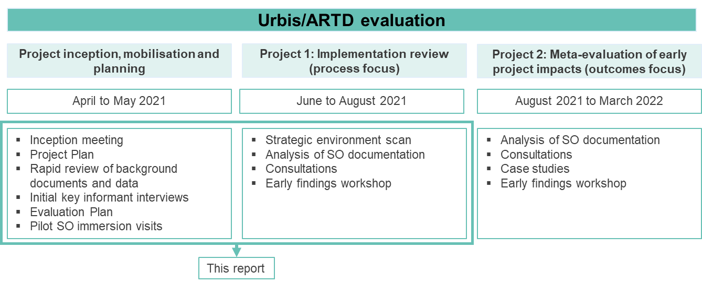Figure 2 – Evaluation overview

The purpose of undertaking an evaluation of the SO Pilots is to collate and distil further key insights that DESE can use to support the future roll out of Industry Cluster arrangements. This includes identifying what worked well for the SO Pilots in establishment and early implementation, and what could be improved to support future success. The evaluation will also provide a baseline for evaluation work to be undertaken in the future.

Key evaluation questions were developed to guide the evaluation. In consultation with DESE, the questions have been updated for this evaluation.

The key evaluation questions for **Project 1** are:

* KEQ1: How effectively has DESE ‘stood up’ the three SO Pilots to position them for success?
* KEQ2: What progress have each of the SO Pilots made in establishing themselves, identifying areas where they can make an impact, and implementing relevant activities?
* KEQ3: What opportunities are there to optimise the establishment of SOs (or similar models) and their implementation of relevant activities?

The evaluation framework is presented in Appendix A and sets out all data sources and their contribution to answering our key evaluation questions.

### Data sources and consultation

This report draws on five key data sources, as outlined in Table 2 below.

Table 2 – Data sources

| Data source | Details |
| --- | --- |
| **Key informant interviews** | We undertook key informant interviews with six DESE staff involved in designing and implementing the SO pilot program and seven SO Pilot senior leaders to understand the background and context of the SO model. |
| **Immersion visits with each SO** | We undertook immersion visits with each SO. The purpose of the immersion visits was to build relationships with each SO, to ensure their staff understood the purpose and scope of the evaluation, to inform any necessary updates to the Evaluation Plan, and to help Urbis/ARTD understand the operating context of each SO and to collect some initial data on SO implementation. |
| **Strategic environment scan** | We undertook a strategic environment scan to understand the environment in which the SOs are operating. This involved reviewing and analysing publicly available information and documents provided by DESE relating to the policy landscape and VET system. Additional information and documents provided during stakeholder consultations were also reviewed. The scan focused on answering the questions: ‘What is the strategic reform environment in which the SOs are operating?’ and ‘What are the challenges for fast and relevant qualifications development faced by each SO?’ |
| **Analysis of SO documentation** | We reviewed and analysed relevant documentation provided by DESE and the SOs relating to establishment and implementation. Funding and governance documents were reviewed to understand the authorising environment in which each SO is operating. Operational documents were reviewed to develop a timeline of implementation to date for each SO. Reporting was analysed to produce a structured assessment of progress against the intended trajectory of each SO and a thematic analysis of successes, challenges and enablers. |
| **Stakeholder consultations** | We undertook consultations with the following stakeholders:   * 21 government stakeholders * 24 SO staff/consultants/project partners * 15 other key stakeholders engaged in the VET sector or SOs’ sectors. |

### This report

This is the report of Project 1. The remainder of the report is structured as follows:

* Chapter 2: Current state – Summarises the current state of play for each of the three SOs, including their pathway to establishment, structure and governance arrangements, activity in progress and aspirations for the future. **Chapter 2 addresses KEQ 2.**
* Chapter 3: Implementation learnings – Explores key insights from the implementation of the three SOs in the context of the program’s objectives and calls out potential opportunities to improve the speed and effectiveness of establishing Industry Clusters in future. **Chapter 3 addresses KEQ 1, KEQ 2 and KEQ 3.**
* Appendices – Appendix A contains the Evaluation Framework and Appendix B contains a summary of stakeholders consulted for this report.

##### The analysis approach

In undertaking analysis of qualitative data informing this report, we adopted a modified grounded theory approach. Developed by Glaser and Strauss, grounded theory is a methodology ​that involves the application of inductive reasoning, a method of reasoning in which evidence (i.e. stakeholder observations and perspectives) is synthesised to develop a theory.[24]

Urbis’ approach involves defining the subject at hand, data collection, followed by an iterative process of engagement between the research team and the data to develop the theory which forms our findings. Adopting this approach allows the researcher to construct theories which are ‘grounded’ in the data.

In this instance, our analysis of qualitative data led to the development of five overarching themes with findings (theories) under each which, taken together, address the three KEQs for the evaluation. Chapter 3 of this report is structured according to these five themes.

Table 3 overleaf presents a summary of the themes and their relevance toward the KEQs.

##### A note on stakeholder perspectives

In undertaking research for this report, we have adopted a ‘purposeful sampling’ approach, which prioritises gathering a diversity of viewpoints, over a representative sample of stakeholders associated with the SO Pilots. In addition, due to the very different perspectives, experiences and degree of engagement stakeholders have with respect to SO, not all stakeholders offered a perspective on all questions within our scope.

For the purposes of this report, we have conveyed the range of perspectives we heard, signalled the degree of consistency of those perspectives (i.e. some, many, most), and where relevant identified the stakeholder group(s) who shared those perspectives (e.g. government stakeholders, SO staff, sector/VET stakeholders).

##### A note on language

We note the Joyce Review used the terminology ‘industry-led’ to refer to the idea of facilitating greater involvement from employers in defining workforce needs and influencing the skills pipeline. For the purposes of this report, we have generally adopted the term ‘employer-led’ in preference to industry-led because ‘industry’ can be interpreted by some stakeholders to be broader than just employers (e.g. it can include peak bodies, unions etc).

Table – Evaluation themes

| Theme | Overview | Relevant KEQ |
| --- | --- | --- |
| The authorising environment | This theme focuses on the relationship between SO establishment and the broader policy environment, including clarity of purpose and authority considering the continuation of the existing system. | KEQ 1 and KEQ 3 |
| Engaging stakeholders | This theme focuses on the effectiveness of stakeholder engagement by the SOs during establishment. | KEQ 1 and KEQ 3 |
| Establishing core capabilities | This theme focuses on core capabilities within the SOs during establishment including recruitment/staffing, corporate capability as well as Board/Steering Group composition. | KEQ 1 and KEQ 3 |
| Deciding priorities and projects | This theme focuses on the SOs’ approach to developing work plans and prioritising their projects. | KEQ 1, KEQ 2 and KEQ 3 |
| Delivering on workplans | This theme focuses on the SOs’ approach to early work program delivery, and some of the factors that enabled or hindered implementation. | KEQ 1, KEQ 2 and KEQ 3 |



# Current state

## Human services

### Establishment

Human services are broadly referred to as the services directed at caring for people and include aged care and disability support. These services fall under the health care and social assistance sector, which is Australia’s largest employing sector. The health care and social assistance sector employs approximately 14 per cent of Australia’s total workforce – more than 1.8 million people – with employment in the sector increasing by 23 per cent since 2016.[25]

In the context of increasing demand for care workers (as a result of Australia’s ageing population and the rollout of the NDIS) and staffing attraction and retention issues, human services was identified as a sector which could benefit from an SO Pilot.

In 2019, the Human Services SO was established with the aim of working with industry to support improvements to the quality and extent of training for the sector and, in doing so, meet growing demand for staff.

The Human Services SO Pilot pathway to establishment involved the key stages outlined in Figure 3.

Figure 3 – Establishment phase timeline: Human Services SO

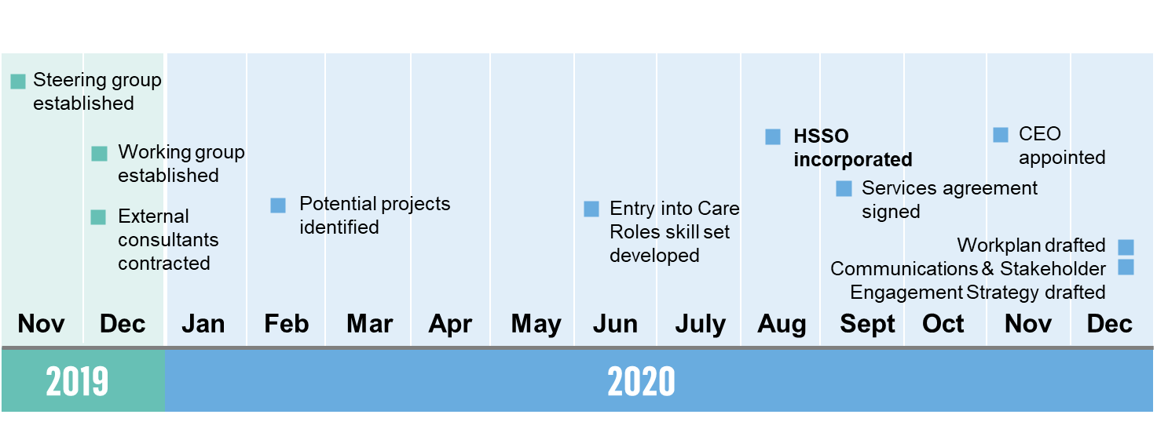

Source: Workplans, reporting and stakeholder interviews

The September to December 2019 co-design consultations, including a human services industry roundtable convened on 25 September 2019, led to the formation of a CEO-level or equivalent Human Services Steering Committee in December 2019, to progress key work of the pilot. Membership of the Steering Group then comprised seven (now five) industry representatives in senior leadership positions nominated by stakeholders based on their capacity and capability to support the Human Services SO Pilot’s objectives and expected outcomes.

The Working Group was also established in December 2019 to provide advice and support to the Steering Group. Working Group members were primarily selected by Steering Group members nominating people in managerial positions from their own organisations. Membership of the Working Group comprised eight representatives from the community services, aged care and disability sectors.

DESE contracted two external consultancies to support the work of the Steering Group in December 2019. One consultancy supported the development of the TOR and the Constitution. The other consultancy provided governance, secretariat, project management and coordination, stakeholder management and evaluation support. The latter also conducted an initial mapping exercise of sector activities, workshopped with the Steering Group and Working Group on the key issues in the sector and proposed pilot projects for the Human Services SO to focus on. This work informed the development of the first Human Services SO Work Plan in February 2020. The Work Plan has subsequently been revised and refined as the Human Services SO has deepened its in-house capabilities, broadened its engagement with industry, and sharpened its view of the strategic challenges the sector faces.

From June to August 2020, the Human Services SO Steering Group worked towards incorporation. The Steering Group looked at various options and came to the view that establishing themselves as a company limited by guarantee would enable them to operate most effectively in accordance with the objectives of the SO Pilot program and the recommendations of the Joyce Review.

The Human Services SO became incorporated as a not-for-profit company limited by guarantee in August 2020, and some members of the Steering Group transitioned to become part of the Board. A range of documentation was developed to support the Human Services SO operations (e.g. agreements, policies and plans), including material required by the contract with DESE and the Corporations Act 2021 (e.g. company constitution).

The Board used an executive search firm to identify key candidates for the CEO position and interviewed a number of candidates as part of this process. In November 2020, a CEO was selected and commenced at the Human Services SO, bringing extensive expertise in both the VET and human services sectors.

From incorporation onward, the main focus for the Human Services SO became industry engagement due to the complex stakeholder environment of the sector (discussed further in Section 3.2). To provide structure to this engagement, a Communications and Stakeholder Engagement Strategy was developed.[26] This Strategy was approved in April 2021.

Stakeholders involved in the establishment period reported a key factor that slowed early work was the impact of the COVID-19 pandemic on the human services sector (e.g. COVID-19 outbreaks in aged care services). A number of Steering Group (now Board) members were not able to consistently engage in activities of the Human Services SO due to having the urgent need to support their own organisations. In some cases, this contributed to turnover in Steering Group members. The pandemic also affected the Board and Working Group’s ability to meet regularly. These challenges are discussed in further detail in Section 3.2.

### Structure and governance

The Human Services SO Board is responsible for strategic leadership, advice and direction for the Human Services SO. The Board determines focus projects (in accordance with the parameters set by the program guidelines) and guides how the organisation will operate in the human services care sector and inform contributions to improvements to national arrangements for skilling the workforce. It currently has five members who work in senior leadership positions across the aged care and disability sectors (see Figure 4 below).

The Working Group provides advisory support for the Board. Prior to the Human Services SO undertaking broader engagement with its employer base in April and May 2021, the Working Group provided employer advice for the Board. The Working Group has seven members (and one vacancy) in middle-management positions across the community services, aged care and disability sectors (Figure 4). The Working Group is being transitioned to a different structure in which members are asked to assist on specific projects on a case-by-case basis.

The Human Services SO team consists of a CEO who runs the organisation, supported by key executive, project and administration roles.

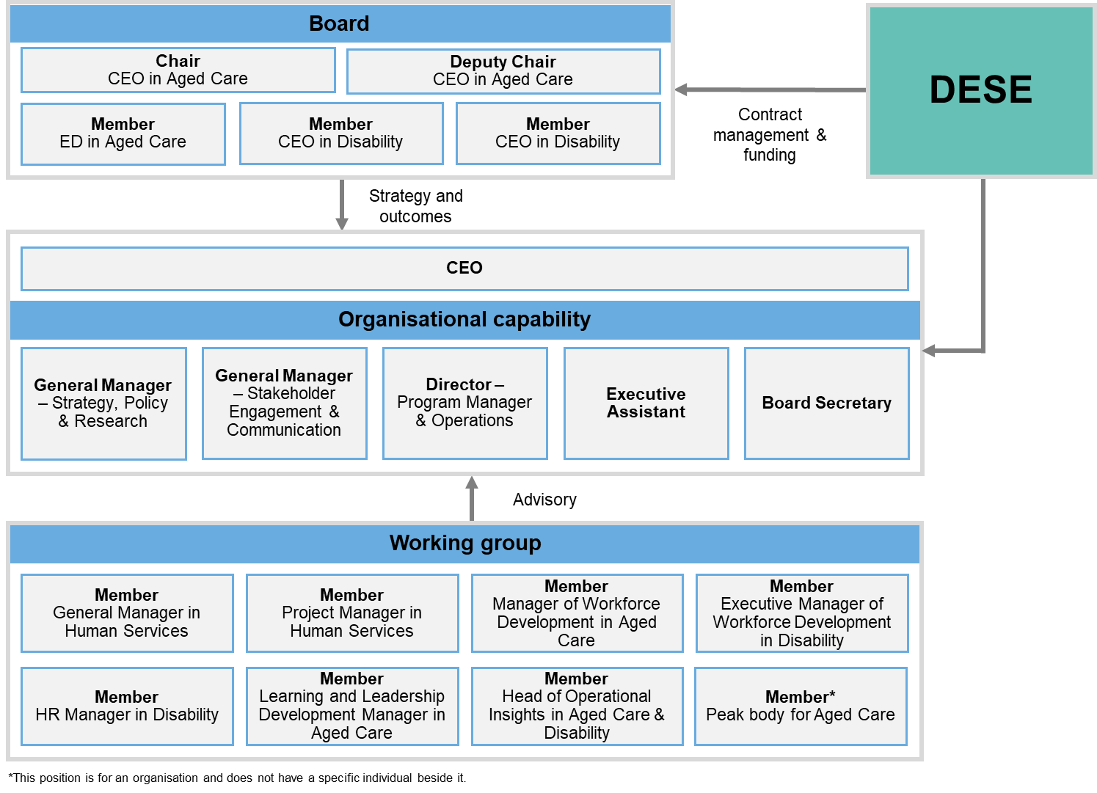Figure 4 – Human Services SO governance structure

Source: Human Services SO – Our Team. <https://hsso.org.au/about/team> / Human Services Skills Organisation, Services Agreement Work Plan 2020-2023 (2022)

### Activity in progress

The Human Services SO has identified various opportunities for pilot projects across the human services and VET sectors. These projects are identified through an ideation process: industry and the Working Group and Board stimulate ideas which are captured in the‘Hatchery’ - ideas that are in ‘incubation’ while they are formed into potential solutions. These ideas are explored with industry and tested with the Working Group. The CEO then provides a project proposal to DESE for approval, to proceed with a pilot project as required under the Human Services SO contract, prior to seeking final approval from the Board. Projects are then trialled and evaluated to assess their effectiveness. Table 4 overleaf outlines the current pilot projects and the Human Services SO’s progress against each project to date.

As outlined previously, the COVID-19 pandemic has significantly impacted the Human Services SO’s early efforts to engage the sector. COVID-19 affected the ability to secure the attention of stakeholders, and also disrupted the ability to physically connect with stakeholders through face-to-face engagement. Despite this disruption, the Steering Group and Working Group were able to successfully develop the Entry to Care Skill Set, which has been trialled through the Brotherhood of St Laurence’s National Skills Training Trial.

Deciding the industries that constitute human services was also a challenge which contributed to some stakeholder confusion about the sectors the Human Services SO was covering. These challenges are discussed in further detail in Section 3.1.

### Aspirations

The Human Services SO expressed motivation to develop strong relationships with industry to better understand what industry needs from the VET system. This would support achievement of their overarching objective to become the conduit between the VET system and industry, ensuring the system is fit for purpose for industry. This is discussed further in Section 3.4.

Table 4 – Human Services SO activity (to August 2021)

|  |  |  |  |
| --- | --- | --- | --- |
| **Activity** | **Description** | **Partners** | **Progress as at August 2021** |
| Evaluation of Entry into Care Roles Skill Set | The ‘Entry into Care Roles’ skill set was developed (with technical support from PWC) to equip job seekers with entry level skills to gain employment in the aged care or disability sectors. It was approved as a time-limited skill set by the Australian Industry and Skills Committee (AISC) Emergency Response Sub-Committee in May 2020.  The skill set has been trialled through Brotherhood of St Laurence’s National Skills Training Trial. It has also been evaluated to understand whether it equips learners with the skills required for employment in aged care and disability support.  Based on the findings of the evaluation, which confirmed the skill set broadly equips learners with the intended skills and knowledge, the AISC agreed in November 2021 to the skill set becoming an ongoing component of the CHC Community Services Training Package. | PWC (design and evaluation)  Brotherhood of St Laurence (trial) | *Completed* |
| ‘How to Engage’ Guide | The development of a best practice guide for enhancing relationships and collaboration between employers and registered training organisations (RTOs). | Sodalite Projects | *In progress* |
| Mandatory Work Placements Guide | The development of a guide/resources to help RTOs, employers and learners to understand the process and requirements of Mandatory Workplace Requirements. | Sagacity | *In progress* |
| Mapping the Sector | The mapping of workforce development and training activities occurring in the human services sector. | Community Services Industry Alliance | *In progress* |
| Industry engagement (including Engagement Roadshow) | Industry engagement with stakeholders (including employers, peak bodies, care workers, customers and community, industry advisory bodies, state and territories, subject matter experts, technical advisors and regulators) across the human services and VET sectors.  Part of this has involved Engagement Roadshow, entailing broad consultations across Australia to inform priorities of the Human Services SO Pilot. Organising and completing this Roadshow has been one of the key areas of focus over the second half of 2021. | Human Services SO | *Completed* |
| Qualification Design Trial | The Qualification Reform Trial has developed new types of training products for the training and assessment of personal care workers in aged care and disability support. This project is taking a conceptual approach to qualification development and focuses on career pathways for the Personal Care Worker job family and will develop occupational standards which reflect the skills and capability requirements for the workforce. | Australian Industry Standards (AIS) | *In progress* |

*Source: Human Services Skills Organisation, Services Agreement Work Plan 2020-2023 (2020); Human Services SO Pilot Projects Overview.*

## Digital

### Establishment

The Australian Government aims for Australia to become a world leading digital economy by 2030.[27] This includes a goal that digitally intensive industries will employ more than 10 per cent of the Australian workforce and that tertiary-advanced digitally skilled graduates will increase to more than 15,000 per year.

To achieve this objective, Australian workers need to be sufficiently trained in digital skills. In Australia, tertiary education and training in digital skills is provided by two groups of organisations: universities and VET providers. The efficiency and effectiveness of VET providers in delivering work-ready graduates was one area of investigation examined by the Joyce Review. One of Joyce’s key findings was that the VET sector was failing to keep up with the rapidly changing digital skills needs of employers. The Digital SO was set up to explore ways to address this issue, noting Joyce’s recommendation that the SO Pilot program include industries such as digital technologies which have a significant need for qualification development, and which do not have strong engagement with the current qualifications system.[28]

A Digital SO Steering Committee was established in December 2019, with members nominated by stakeholders who participated in the co-design consultation process (including the Digital Skills roundtable held in September 2019). Steering Group members were typically individuals with a strong background in the technology sectors.

The Digital SO became incorporated as a not-for-profit company limited by guarantee in June 2020. Following incorporation of the Digital SO, some members of the steering group became part of the Digital SO’s Board.[29]

The Board hired the Digital SO’s CEO, following an executive search in October 2020 (noting a Chief Operations Officer had already been appointed in July 2020). Following the appointment of the CEO, the Digital SO developed a two-year business plan which was subsequently approved by the board. The Digital SO’s two-year business plan was consistent with the Digital SO terms of reference (i.e. that the Digital SO’s mandate was to prove the case for change through pilot programs).[30]

By the end of 2020, the Digital SO had hired the Bids and Project Manager (now Chief Operation Officer), Communications Manager and two more staff: one with experience working in the VET sector; and another with experience working in marketing and communications. At the start of 2022, the Digital SO had 15 full or part time staff.

The Digital SO described its trajectory in three stages:

* Phase One, “Trial, Evaluate and Adapt” (Oct 20 - Jun 21) saw the Digital SO Work Plan approved, the Evaluation Framework completed, the V1 Skills Assessment Model approved, the Discovery Phase completed and a Showcase Programme commencing.
* Phase Two, “Expand and Scale” (Jun 21 - Jun 22) is focused on testing the Digital Skills Development Model (the DSDM or the Model) at scale and commencing discovery of the future delivery model.
* Phase Three “Scale and Transition” (Jun 22 - Jun 23 +) will see the roll out of the DSDM and the Operating Model achieved and integrated.

Digital skills pathways aim to identify national digital skills priorities. The digital skills assessment framework aspires to an independent test of the skills that training is intended to provide to a learner to assess the fit between the skills of an individual and workplace requirements that is agnostic about how skills were acquired. The engaged communities component aims to extend the original focus on engaging with a group of large (E20) and small employers and (G20) to include other key stakeholders of the VET system.

The Digital SO Pilot pathway to establishment involved the key stages outlined in Figure 5.

Timeline graphic, highlighting the key stages in the Digital SO Pilot from 2019 to 2021.Figure – Establishment phase timeline: Digital SO

Source: Workplans, reporting and stakeholder interviews

### Structure and governance

As noted above, the Digital SO is governed by a Board and currently has seven Board members at the date of this report, meeting approximately every six weeks. As shown in Figure 6, the Board is supported by the Finance and Risk Committee, the CEO and by finance, legal, marketing and communications expertise. The Digital SO has a close relationship with DESE and other key stakeholders and is also informed by small to medium enterprise expert panel/forums from time to time.

The organisational structure is underpinned by agreements, policies and plans endorsed by the Board against the requirements as set out under the Commonwealth's contracts and consistent with requirements under the Corporations Act 2021 (e.g. company constitution).

Figure 6 – Digital SO governance structure

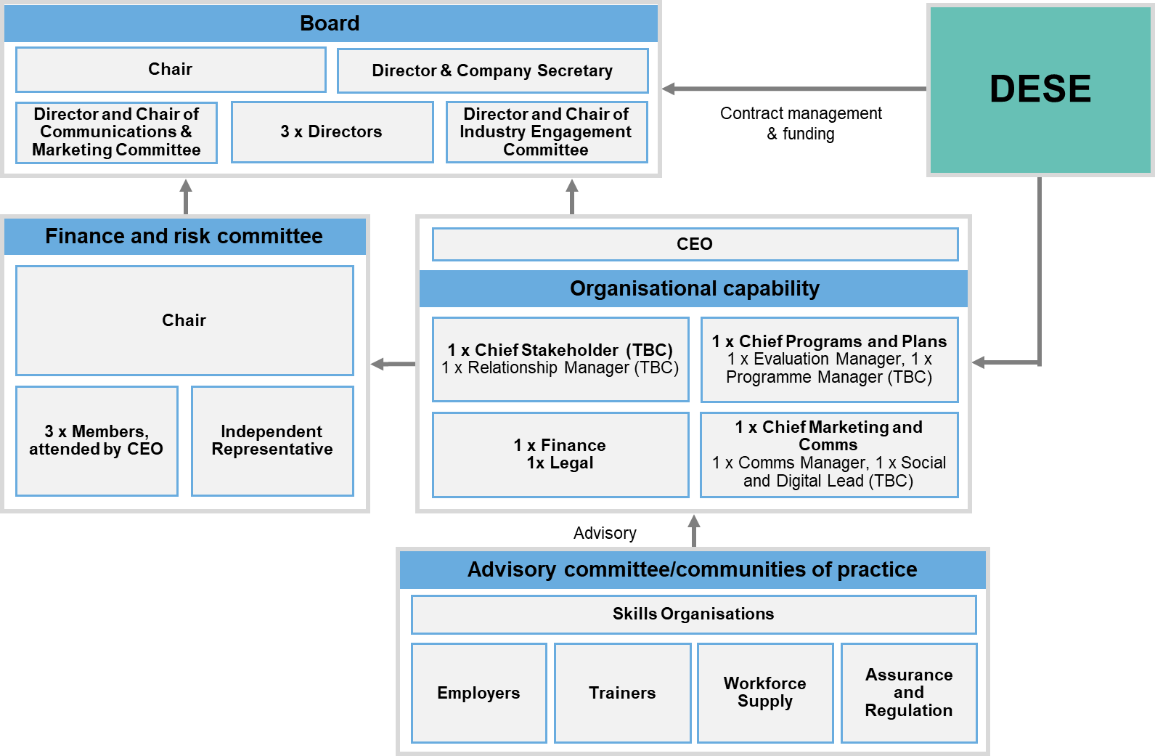

Source: Digital Skills Organisation Work Plan: Strategic Direction and Two Year Work Plan (2020)

### Activity in progress

Table 5 – Digital SO activity below outlines Digital SO activity, activity partners and progress to date.

Table 5 – Digital SO activity (to August 2021)

|  |  |  |  |
| --- | --- | --- | --- |
| **Activity** | **Description** | **Partners** | **Progress as at August 2021** |
| Train 100 analysts | Seeks to train 100 data analysts through an employer-led approach that allows training providers the opportunity to create course content specific to employers’ needs. | Goanna, General Assembly and TAFE Queensland | *In progress* |
| Qualification design trial | Explores how employers can best engage with VET and how learners can navigate the range of available nationally endorsed training options to achieve the best skilling and occupational outcomes. It also considers what may be required to support training providers successfully transition to delivering new training products. | PWC and DESE | *In progress* |
| Delivery program one | Development of an employer-led assessment model. | TBC | *TBC* |
| Delivery program two | Digital Career Pathway project aims to make digital careers more accessible through stakeholder collaboration and included digital fluency. | Digital Transformation Agency | *In progress* |
| Delivery program three | Focuses on creating a community of stakeholders to build strong strategic partnerships. | Made up of two groups, one of larger enterprises (E20) and the other with smaller players (G20). | *In progress* |

### Aspirations

The Digital SO is developing strong relationships with a wide range of selected employers, training providers, peak bodies and other stakeholders to focus on training that leads to jobs. The Digital SO has concentrated on the identification and evaluation of specific training offerings in the market and new modes of assessing the skills of graduates of training. In both cases it is focused on employment related outcomes as the arbiter of success. This reflects a ‘start-up’ culture of demonstrating fast and responsive alternatives to the current VET system approach to training to ensure digital training meets the skills needs of employers. As a result, there has been less emphasis on engagement with the existing approach to the development of training packages for accredited training.

The identified focus of the Digital SO over the next six to twelve months is to continue to implement their work plan, scale up and progress the current initiatives in place or under development.

## Mining

### Establishment

The mining industry employs almost two per cent of Australia’s total workforce – more than 250,000 people– and is experiencing major skills shifts as a result of new technologies and changing global demands.[31] Mining is also Australia’s largest sector by share of total national Gross Domestic Product (GDP), accounting for approximately eleven per cent of GDP between 2019 and 2020.[32] When the Mining Equipment and Technology Services (METS) sector is included, the total workforce directly supported by these sectors is an estimated 483,000 Full Time Equivalent (FTE), rising to 1.1 million jobs when indirectly supported roles are taken into consideration.[33]

In response to the sector’s changing skills landscape and its importance to the Australian economy, the Australian Government announced in late 2019 the commitment of additional funds through the Mid-Year Economic Forecast for the establishment of the Mining SO. This built on the Australian Government’s earlier commitment to establish SO Pilots in the human services and digital technology sectors.

The Mining SO was established in May 2020 through a co-contribution model with the MCA, although establishment work commenced on 1 November 2019. Under the co-contribution model, the Mining SO is auspiced by the MCA, with intention to incorporate in the second half of 2021. The MCA also provided in-kind support to the Mining SO including three full-time staff, office space, and access to internal support functions such as finance, communications and marketing.

In the lead up to establishment, the MCA developed an interim governance framework for the Mining SO, consisting of a Steering Group and a Working Group and supported by Terms of Reference (TOR). The TOR were developed in line with the program guidelines and Mining SO contract. The interim structure for the Mining SO is a ‘hub and spoke model’ which seeks to leverage the networks of Steering and Working Group members to capture broad industry engagement and input. MCA standing committees also contributed to this process.

As outlined in the TOR, the vision for the Mining SO is for an industry-owned/led approach to education and training for Australian mining that:

* ensures the skills needed by the sector and the broader Mining Equipment and METS sector industries are met
* equips learners in the current and future workforce for work in the modern mining sector.[34]

To determine focus projects and a forward work program, the MCA initially held a series of national workshops with stakeholders from industry, education and training providers, government representatives, Industry Reference Committees (IRCs), and Skills Services Organisations (SSOs) and peak bodies. The primary purpose of these workshops was to identify priority aspects of the skills pipeline that stakeholders felt the Mining SO could influence. Priorities identified through the workshops were then refined through numerous consultations and planning sessions with the Mining SO Steering Group and Working Group to develop the overall strategy and operational priorities for the Pilot. These priorities ended up forming the basis of the Mining SO’s forward work plan that was approved by DESE in November 2020.

In mid-2020, the Mining SO Steering Group endorsed three project hubs for priority development: Apprenticeships, Digital Transformation and Attraction and Retention. The Mining SO is also undertaking a fourth project hub (Qualification Design Trials) to address the Skills Ministers’ commitment to trialling new evidence-led approaches to qualification design.[35] From December 2020 to January 2021, the Mining SO undertook a procurement process to engage partners to support activities under each project hub.

The Mining SO’s pathway to establishment is summarised in Figure 7 overleaf.

*Figure 7 – Establishment phase timeline: Mining SO*

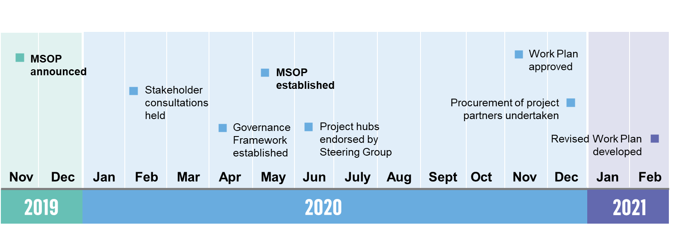

Source: Workplans, reporting and stakeholder interviews

### Structure and governance

As noted above, the MCA was responsible for leading the first stage of the Mining SO and engaging with employers, broader industry and national VET stakeholders on changes to improve the quality of training for the sector.

The Steering Group was responsible for providing strategic leadership, advice and direction for the Mining SO while it operated within the MCA, akin to a board. Membership of the Steering Group comprised six industry representatives who were invited based on their capacity and capability to support the Mining SO’s objectives and expected outcomes. Three advising observers were also appointed, including DESE First Assistant Secretary, VET Quality and Policy Division and representatives from the education and training sector and state chambers. While the Steering Group was industry-led, the relevant expertise of broader stakeholders (government, education and states) was brought to the table to ensure that their perspectives were heard at the right time and that there was early cohesion/investment in project hubs.

The Working Group was responsible for providing the stakeholder engagement mechanism and expert input for the operation of the Mining SO. Membership of the Working Group comprised twelve representatives from four stakeholder groups: industry, education and training, current structure entities and other (industry, peak or professional bodies). Working Group members were selected through an expression of interest process.

The interim structure for the Mining SO is depicted in Figure 8.

Figure 8 – Mining SO governance structure  
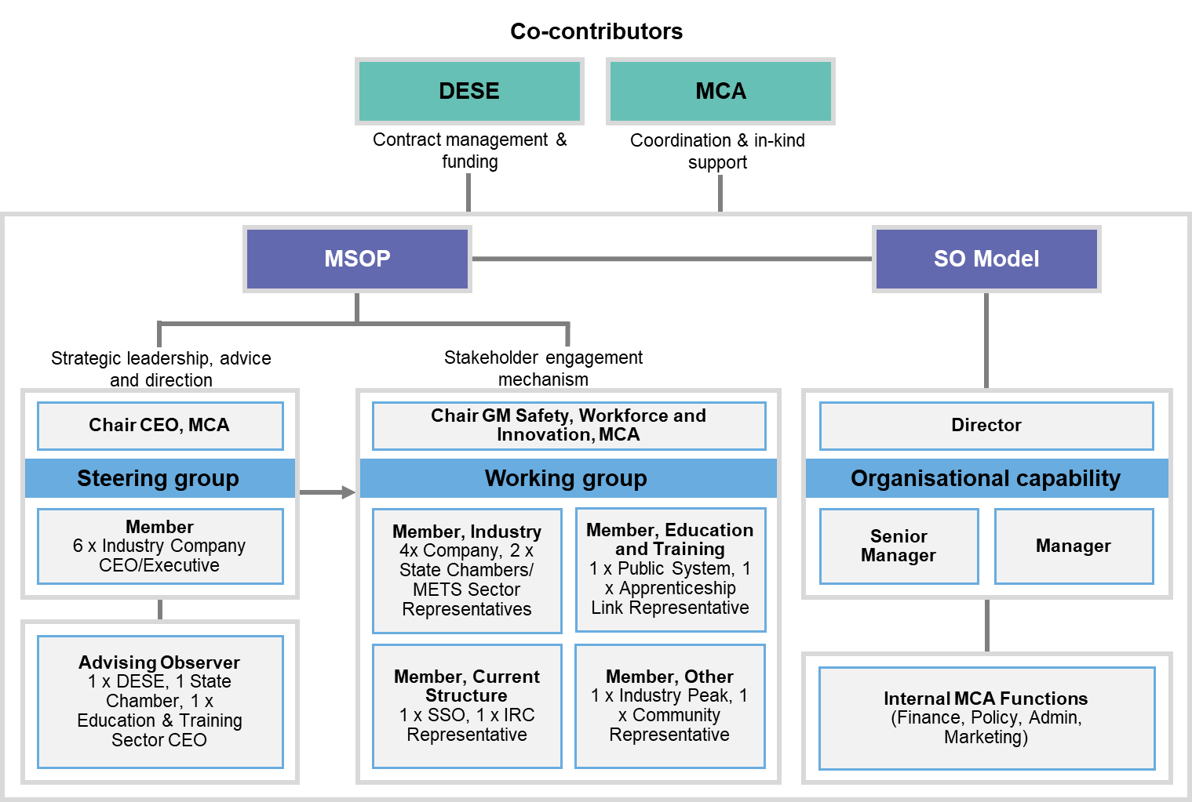

Source: Mining SO Forward Work Plan (2021), Urbis

### Activity in progress

The four project hubs that comprise the Mining SO’s forward work are summarised in Table 6 below. Under the Mining SO’s hub and spoke model, Steering and Working Groups members are aligned to one of the four project hubs.

*Table 6 – Mining SO activity in progress (to August 2021)*

| Project hub | Description | Partners | Progress as at August 2021 |
| --- | --- | --- | --- |
| Apprenticeships | Seeks to modernise how skilled tradespeople are produced in a timelier way. Initially focusing on a pressure point within the industry – diesel mobile plant mechanics. | The Meyvn Group (consultants), Rio Tinto, FMG, BHP, WesTrac, South Metropolitan TAFE | *In progress* |
| Attraction and Retention | Seeks to position mining as an industry of choice through developing, testing and activating a framework for attracting and retaining the talent pipeline the sector needs, now and into the future. | NCVER (consultants), Curtin University, North Metropolitan TAFE, CQU (noting this project has many different components, Mining SO have only activated two components at the time of writing this report) | *In progress* |
| Digital Transformation | Aims to develop and test a mechanism which will allow accredited training products developed for the sector relating to automation and the application of digital technologies to be part of Australia’s nationally recognised training product library. | Avenir Consulting (consultants), Rio Tinto, South Metropolitan TAFE, WA Government (the industry partners in terms of automation qualifications that have already been developed) | *In progress* |
| Qualification Design Trials | Seeks to test the development of new broad-based qualifications and skill sets that relate to job clusters or job families in the mining industry. | Meyvn Group (consultants), Rio Tinto, FMG, BHP, WesTrac, South Metropolitan TAFE, DESE | *In progress* |

Source: Mining SO Forward Work Plan (2021), Mining SO Procurement Plan (2020), Urbis

### Aspirations

In the second half of 2021, the Mining SO transitioned to a standalone entity (i.e. a company limited by guarantee). The MCA worked with DESE to plan and manage risks associated with the transition, particularly in relation to stakeholder engagement and activity prioritisation.

The Mining SO is also focused on progressing activities in each project hub, including toward the following key milestones:

* Apprenticeships: Identification of pilot training program participants and commencement of training program (Jul-Dec 2021)
* Attraction and Retention: Evaluation of capability sets (Sept-Dec 2021)
* Digital Transformation: Testing of a mechanism to facilitate the timely development of future digital-based training product content and implementation of new content (Sept 2021-Feb 2022)
* Qualification Design Trials: Development and implementation of trial products (July 2021-Mar 2022).

# Implementation learnings

## The authorising environment

### Key findings

* DESE’s supportive approach, which provided flexibility for SOs to operate with a degree of strategic autonomy within the framework established by the program guidelines, lent credibility to their identity as employer-led.
* Establishing employer-led steering groups and subsequently SO boards helped establish SOs’ credibility and authority within their sectors.
* Each SO has needed to manage how their remit crosses over with policy activity or initiatives driven by different government portfolio areas, although the degree of practical impact varies.
* Establishing the SOs as pilots without confirming the next stage of reforms (since resolved with the 2021 Budget announcements) created some sector confusion and challenged relationships with some elements of the existing system.
* Each of the SOs showcases a different way to define the industry from which they require both formal and informal authority to operate effectively.

### Introduction

The Joyce Review recommended that SOs be industry-led and assume a leadership function in support of a VET system that better meets the needs of employers, the economy and learners. SOs were established to “operate as employer-led organisations with genuine, transparent and broad representation and support across their industries”.[36]

This chapter addresses the extent to which the authorising environment for the SOs has been established. The right authorising environment is fundamental to enabling SOs to deliver on their agenda, and includes formal authority (e.g. legislative or administrative delegations) and informal authority (support from ‘mission-critical’ stakeholders).[37]

### Employer leadership in establishment helps to create credible organisations

The ‘employer-led’ aspect of the SOs approach is a defining characteristic of the model. To support this, for each of the SOs, early planning involved the establishment of a steering committee and working groups, primarily drawing on employer perspectives. In the case of the Human Services SO and the Digital SO, the steering committee transitioned into a board after incorporation.

The early investment by DESE in engaging with employers to co-design the SO models has proven important to establishing organisations as products of industry rather than government. This commitment to early engagement and genuine co-development provides a strong foundation for SOs’ industry credibility as organisations driven primarily by the workforce needs of employers.

DESE and stakeholders internal to the SOs reported the approach to early leadership was focused on building credible, expert-led governance structures, rather than pursuing a form of representational governance. However, within these contexts, the importance of exposure to different sub-sectors and contexts was also noted.

### A collaborative and flexible approach by DESE enables employer leadership

The SO Pilots program guidelines establish the broad parameters for action by SO Pilots and place emphasis on engagement with industry and strengthened industry leadership in the determination of priorities. Activities proposed for funding in SO workplans must be based on consultation with industry, align with the skills pipeline and demonstrate a clear benefit to the VET system and its end users.

In this context, many SO staff reported they have been enabled to operate with a relatively high degree of strategic autonomy, while feeling able to draw on support or advice from DESE as required. The combination of support-as-needed and scope for flexibility has helped create an operating environment where SOs have been able to work in genuinely employer-led ways from the outset.

Most SO staff reported the flexible and collaborative relationship they hold with the core DESE team has been enabling during the establishment and implementation periods. When asked to characterise their relationship with DESE; their responses emphasised an experience of mutual respect, trust and support.

The fact that they… can actually choose to tackle the issues that are most critical to their industry … is just fantastic. – SO staff/consultant/project partner

Notwithstanding the relative autonomy afforded the SOs, their work plans have been developed with input – and ultimately approval – from DESE. However, we heard from some VET/industry stakeholders (generally those less directly involved in the SOs) that the strategic freedom brought with it some risk of divergence from the broader reform agenda.

### Uncertainty about the policy intent impacts the authorising environment

The SOs were established as pilots during a period of policy transition and ongoing development of the VET reform agenda. In this context, there has been some uncertainty among many VET/industry stakeholders about how the SOs intersect with the existing VET system and the reform process. Many stakeholders – both internal and external to the SOs – described a lack of clarity around specific intersections of scope with the ongoing work of IRCs and SSOs.[38]

We heard a considerable diversity of views from stakeholders we engaged with, reflecting different levels of understanding of the SO pilot mandate, and of the longer-term reform intent. We heard, for example, that:

* Some VET/industry and government stakeholders perceived that *SOs risked duplicating existing effort* (most prominent in the human services sector), and that potential areas of work or projects may require negotiation with other entities within the system.
* In some cases, stakeholders who were invested in the existing system were reportedly reticent to engage and/or collaborate with the SOs, because they *perceived a lack of clarity about SO pilot scope*.
* Some VET/industry stakeholders reported that employers and industry peak bodies *wanted assurance the new SO model would maintain or improve the level of industry engagement* in the VET system (notwithstanding that this is a primary stated intent of the program).
* Conversely, some VET/industry stakeholders and a small number of government stakeholders described the *SOs were set up to be partly disruptive* as small, agile and independent entities with a broad mandate to explore ways to build a more industry-responsive skills pipeline.

Stakeholders within SOs and government anticipated that the 2021 Budget announcements of the introduction of Industry Clusters would provide clarity about the ‘post-pilot’ future. Our consultations occurred around the time budget announcements were made, and we heard from many stakeholders that there is a desire to understand how and when these reforms will intersect with – or replace – the existing system architecture.[39]

Clearer articulation as to how [the SOs] fit within the existing framework [is desirable]… what is the relationship between the Skills Organisations pilot, the existing SSOs and the IRCs? And then of course we’ve got the 15 new Skills Enterprises coming up which were announced in the Budget. – VET/industry stakeholder

### Clear communication helps shape the ‘informal’ authorising environment

Building clarity around the purpose and mandate for SOs lays the groundwork for SOs to engage and collaborate with system actors and to leverage the ‘informal’ authorising environment within the broader VET system.

However, several factors have impacted how effectively this has occurred to date. These included the fact that the Joyce Review, while introducing the concept of the SO model, does not fully prescribe how they would operate in practice or where priorities should lie – as this needs to be defined by industry itself under an industry-led model. The iterative approach to policy formulation and model development has meant that it has not been possible to deliver complete and early clarity to all stakeholders.

A key early task for each SO was to develop and execute a communications strategy as part of their engagement and mandate-building efforts within their industries. However, each SO told us that the COVID-19 pandemic has made it difficult to engage stakeholders widely and face-to-face in a practical sense, while also requiring focused responses across many sectors (particularly the human services sector). The pandemic has in this way impacted both communication channels and audience attention.

Each of these points are likely to be at least partly resolved as the policy parameters have solidified and Australia continues to adapt to a new ‘COVID normal’. However, a third complicating factor is that communicating the SOs’ scope and purpose is also made intrinsically more difficult by the complexity of the existing training system, the ongoing nature of the reform transitions and the diversity of language and operating contexts across different sectors.

In this context, to ensure stakeholders invested in the current VET system clearly understand the purpose of the reform, we suggest that DESE prioritise delivery of clear messaging of the place of SOs within the longer-term reform agenda. This may include articulation of what the reformed system looks like and the expected roles and responsibilities of stakeholders in the system (noting this has largely occurred through the information on Industry Clusters now publicly available).

### Government activity outside the DESE portfolio impacts the SO mandate

A complicating factor within the broader strategic environment for SOs is the impact of policy action driven by other areas of government that crosses into the skills and workforce space. The nature and extent of the impact was different for each SO, but each provides a useful case study for how these can potentially generate role confusion within particular sectors.

The Department of Health auspices the Aged Care Workforce Industry Council (ACWIC), which implements the strategic actions outlined in the *A Matter of Care: Australia’s Aged Care Workforce Strategy*.[40] We heard from a small number of VET/industry stakeholders and SO staff that the scope of work for ACWIC as set out in the Strategy potentially overlaps with the brief given to the Human Services SO – for example, in defining new career pathways and reviewing the Certificate III in Individual Support (Ageing, Home and Community).[41] While the Human Services SO and ACWIC have established a CEO-level relationship to manage risks of duplicated effort and negotiate areas of work, there remains an underlying overlap of organisational mandates. This core issue was also signalled in the decision by one Human Services SO Steering Group member involved in both organisations electing to step out of their Human Services SO role due to perceived conflict of interest – rather than leveraging what might otherwise have been seen as an opportunity to ‘network’ the organisations at board level.

The recently released *Australia's National Resources Workforce Strategy* is led by the resources portfolio agency, the Department of Industry, Science, Energy and Resources (DISER).[42] The strategy aims to support job opportunities and workforce participation in the resources sector and is a positive example of cross-departmental coordination. The Mining SO is referenced within the strategy among a range of Australian Government investments and acknowledged initiatives underway in industry and within the Mining SO. Mining SO stakeholders reported they were closely engaged with DISER in the development of the strategy and felt well accommodated within it, noting one of the strategy’s action items specifies the need to shape the VET system to be more responsive through the Mining SO.

In the case of the Digital SO, many sectors and industries are grappling with the need to upskill workers in digital skills and there is a proliferation of policies and strategies across portfolios which address digital skills development. Of note is the *Digital Economy Strategy 2030,* established by the Department of Prime Minister and Cabinet (DPM&C),[43] which outlines a vision for Australia to have the leading digital economy by 2030. The strategy describes a very broad range of concurrent digital workforce initiatives; the Digital SO are cognisant of this work and are carving out a clear role for their organisation in a busy policy space.

It is apparent that government departments (at both federal and state levels) are engaged in initiatives that have potential to overlap or duplicate efforts of the SOs. Cross-governmental collaboration is needed to ensure approaches are integrated, not duplicative. We suggest DESE continues its efforts in advocating the role of SOs within government, creating pathways for SOs to engage with other portfolios, and facilitating clear and consistent communication between SOs and government about whole-of-government or cross-portfolio activity in the workforce and skills space.

### Defining the ‘industry’ playing field presents specific challenges

We heard from some SO staff and VET/industry stakeholders that defining the boundaries of the industry in scope for SOs was a complex and necessarily imperfect task. Each SOs’ experience and approach offers specific insight into the challenges and implications of differences in definitional approach.

Initially, DESE hosted industry roundtables with stakeholders from sectors they intended the SOs would cover. The Digital SO roundtable involved Information and Communication Technology (ICT) sector stakeholders, including Microsoft, Telstra, NBN co, NAB, Westpac, Quantium as well as industry peaks and small business representatives. Rather than defining itself around ICT employers, the Digital SO has ultimately adopted a ‘horizontal’ (or cross-sectorial) concept of digital industry scope, which reflects the growing universality of digital skills and their applications in many different industries and sectors. This extends to concepts of digital fluency in the general workforce, and in the form of digital specialists.

The Human Services SO is different again, with emphasis on industries providing human services or care. The early roundtable convened by DESE comprised representatives from the disability, aged care and early childhood education and care (ECEC) sectors. However, early challenges were encountered in engaging the ECEC sector within its remit, in part because of the emergence of stronger alignment within that sector as ‘education’ providers rather than providers of childcare. The Human Services SO continues to engage with the ECEC sector, and its projects cover all sectors included in its scope (aged care, disability, veteran’s affairs, and ECEC).

The key observation to make here is that self-identity can matter in the definition of industry. However, it is also clear that grouping aligned industries together creates opportunities for economies of scale, and allows similar sectors to leverage off one another and work collaboratively towards common goals.

These reflections point to the importance of early engagement with industry stakeholders to explore which points of commonality will inform each unique definition of industry, and that the particular dynamics within industries (however ultimately defined) will shape the ‘right’ structure, priorities and approach for each SO.

## Engaging stakeholders

### Key findings

* The broad based, ‘whole economy’ nature of digital skills required a different engagement approach to sectors defined more clearly by employer-activity (mining and human services).
* The strategic environment impacts stakeholder attention – for example, the human services sector has been significantly impacted by COVID-19, and through contributing and responding to two Royal Commissions. COVID-19 also adversely affected the Mining SO’s engagement with stakeholders, and limited on-site contact.
* The Mining SO’s origin in an established, well known and credible organisation enabled early movement to stakeholder engagement, while the Human Services SO and Digital SO required investment in organisation building before broader stakeholder engagement could commence.
* While the Mining SO has leveraged the MCA platform, the Human Services SO and Digital SO are taking more time to build consistency in communicating their strategy to their broader stakeholder networks.
* Stakeholder uncertainty about the longer-term role of SOs, and concerns about the changing balance of influence from those with vested interests have been inhibitors to SO engagement.
* The diverse experiences of the SOs demonstrate how a cohesive or fragmented industry will shape industry engagement strategies.

### ****Introduction****

Each SO Pilot was tasked with leading industry engagement in the VET sector, strengthening “sector networks and feedback loops” and working with the national VET system to influence changes that will improve vocational training for their industries.[44] The program guidelines also specifically signal the need to secure industry support for governance arrangements and both industry and VET sector agreement for proposed activities.[45]

The SOs operate in a highly complex, dynamic, and crowded stakeholder environment. To at least some extent, their early successes depended on effective engagement with key stakeholder groups including employers, governments, RTOs, IRCs and SSOs, sector peaks and unions.

### ****Industry structure and strategic environment shapes engagement models****

The different characteristics of each SOs’ industry has informed different approaches to how each SO has engaged with its stakeholders, and which groups have been prioritised.

The Mining SO operates in a concentrated and relatively cohesive sector, where its auspice body, the MCA, represents companies that produce more than 85 per cent of Australia’s minerals output.[46] With most of the big mining players already represented by the MCA, the Mining SO was able to rapidly mobilise industry in the lead up to establishment. However, these circumstances are most likely unique. The establishment of the Mining SO had its origins in advocacy by a self-defined sector (mining and METS) and associated peak body, with co-contribution from industry also signalling investment in the concept from the outset. Many VET/industry and government stakeholders were generally of the view that the Mining SO experience is unlikely to be fully replicable at the scale of larger Industry Clusters.

Without the benefit of an auspice body providing a clear industry definition, communications platform and pre-existing networks, industry engagement required more intensive effort by the Human Services SO and the Digital SO. We heard from many SO staff, VET/industry and government stakeholders that the Human Services SO operates in a particularly complex space, with their work spanning multiple diverse sub-sectors and a very large number of employers with different scales, strategic priorities and interests, and that simply getting in touch with them is difficult.[47] The human service sectors are also generally organised around a large and complex network of peak bodies who represent or advocate for their constituent organisations – many of whom are undertaking activities or niche projects that overlap with the Human Services SO’s remit.

A third factor influencing engagement with the human services sector is the immense level of public scrutiny arising from the Disability and Aged Care Royal Commissions,[48] and the impacts of COVID-19. These have impacted priorities in the human services sector and meant stakeholder attention has been directed elsewhere.

In contrast to the Human Services SO, we heard from some SO staff, VET/industry and government stakeholders that COVID-19 had no discernible impact on the Digital SO’s industry engagement, as its staff and many of its primary industry stakeholders communicate online regardless of circumstance. The Digital SO’s stakeholder environment is also very broad and complex, with their employer stakeholder cohort including all those that require a digitally skilled workforce within and beyond the technology sector (i.e. the majority of Australian businesses now and into the future).[49] This very broad definition of the employer stakeholders presents its own challenges to developing an engagement strategy that needs to be effectively economy-wide. The industry is also characterised by significant diversity in employer scale and sophistication, requiring an approach that engaged a range of perspectives.

The nature of the industries are all so very different and precludes a one size fits all [approach]. Certainly you have got market concentration in… mining but also concentration in the number of employers, whereas in human services you have probably tens of thousands if not hundreds of thousands of employers who need a consistent training system and when you get to digital it feels like in between there are… some really big players but also lots of other smaller players so the different ways that these industries are going to require very different approaches. – VET/industry stakeholder

The Human Services SO and Digital SO adopted strategies that respond to the scale, structure and strategic environment of their industries. The Digital SO leveraged its board networks, and a partner organisation to identify a broadly representative group of 20 larger enterprises (E20) and a group of 20 smaller employers (G20), to be engaged within an advisory committee or communities of practice approach, providing ‘sounding boards’ for their work. Their early focus is to work closely with these reference groups to understand how they can shape and influence behaviour, and to build credibility with the broader market through proof-of-concept and proof-of-scale projects.

Human Services SO also pursued a broader engagement “roadshow” aimed at building broad-based awareness across its industry sectors, building the value proposition, and shaping how it prioritises activities through a relatively open approach to consultation. Human Services SO is also seeking to map and understand existing skills-related activity within the sector to address duplication risk.

While the SOs share broadly aligned goals around influencing employer engagement with the VET system, the strategic landscape in which each has been established is markedly different. This impacts the way stakeholders, particularly employers, are engaged and signals that approaches employed by the future Industry Clusters will need some flexibility depending on their industry contexts.

### Progress of engagement is influenced by internal and external factors

Each SO has developed a stakeholder engagement strategy to guide their communication with key groups. While the strategies are consistent in many of their core elements (stakeholder definitions, key messages, and engagement principles), they vary in scope and method and are at different stages of execution. While taking this into account, there are conflicting views about SOs’ success in building stakeholder engagement and subsequent support for the SO activity.

The Mining SO’s ability to leverage the platform and operational support offered by the MCA, and a relatively simpler stakeholder eco-system, facilitated a relatively swift transition to stakeholder engagement, with less early human investment in legal and governance processes associated with establishment. As noted in Section 2.3, the Mining SO held a series of workshops in early 2020 with representatives from industry, RTOs, Government, IRCs and SSOs, unions and peak bodies to identify potential focus projects. These workshops appear to have served their dual purposes of gathering input from key groups and in securing early stakeholder buy-in.

Stakeholders within government, internal and external to the SOs reported that the Human Services SO and Digital SO were not yet consistently and clearly communicating their operating strategy to the broader stakeholder network. Some stakeholders we spoke with were uncertain of what the SOs are trying to achieve. However, as discussed above, the breadth, complexity and diversity in the stakeholder landscape for the Human Services SO and Digital SO does present specific challenges in consistently reaching all audiences.

At the same time, some SO staff and VET/industry and government stakeholders closer to the establishment process have acknowledged that the Human Services SO and Digital SO’s capacity to engage with key stakeholders has been constrained during the establishment period. Initial delays are partly attributable to the significant time and effort taken to secure staff to lead engagement, and to build credibility and identity within their sectors (see Section 3.3). The Mining SO has benefited from leveraging MCA industry presence and connections – but will likely be faced with re-establishing its credentials as a separate entity after separating from the MCA in late 2021. This re-establishment period will be occurring while the organisation simultaneously seeks to deliver its work program.

The impacts of COVID-19 on how each SO engaged its stakeholder network varied. COVID-19 affected the means of engagement and communication channels, as well as the extent to which ‘audience attention’ could be captured. In our view, the impacts of COVID-19 were greatest for the Human Services SO – primarily because of the deep impact on aged care and disability sectors. Senior Human Services SO stakeholders also described the internal challenges of maintaining momentum and focus, especially as most steering ground and subsequently board members are CEOs of organisations that were heavily impacted by the pandemic. To address this, the Human Services SO firmly focused on its Engagement Roadshow (see Section 2.1), which took place in the second half of 2021.

We also head from SO staff that the Mining SO’s establishment and set up were also materially affected by COVID-19, although to a lesser extent. The pandemic impacted access to stakeholder and industry sites, impacting on consultation that was critical to the initiation of the forward work program. COVID-19 disruptions also contributed to holding up the public announcement of the Mining SO (and effectively the ‘go’ signal for broader sector engagement).

While the Digital SO engaged early with key players in the information and communications technology (ICT) sector, some VET/industry and government stakeholders suggested they were slower to link in with the VET system. In part, this is attributable to the early Digital SO team’s strengths and networks lying predominately within the ICT sector, rather than in the VET system, and with the SOs set up as being employer-led.

For the Human Services SO and Digital SO, slower than planned stakeholder outreach reflects a combination of external circumstances and the time required to establish an entity, recruit staff, identity and clarify organisation purpose: all pre-requisites for broad based engagement.

[Stakeholder engagement] is ramping up more and more as we go on which is really good, but I don’t think all our stakeholders appreciated kind of how long it takes to set up new organisations to get them out and about. – Government stakeholder

### Resistance to the new model is a challenge to broader industry engagement

As discussed in Section 1.1, the SOs were established as pilots to trial new ways of working to shape the national training system to be more responsive to skills needs. The intention was that lessons learnt through the pilots would help inform broader improvements to the national VET system.

The establishment of SOs as pilots before broader reform directions (and specifically Industry Clusters) were publicly confirmed meant that the SOs have operated without affirmation of a long-term role within the VET system. For some stakeholders, this lowered the incentive to engage constructively with the SOs, particularly where coupled with a degree of reform fatigue among VET system stakeholders. In addition, for some stakeholders with vested interests in the current system from IRCs and SSOs, there were concerns about changes to the balance of influence in transitioning to an explicitly employer-led model. We heard strong views from a very small number of stakeholders about the Joyce Review itself which suggest that some may be implacably opposed to the reforms.

Taken together, these factors have contributed to scepticism from some VET/industry stakeholders about the SOs themselves which is likely to have impacted engagement efforts in some quarters, particularly peaks, professional associations and unions.

The [SOs] are not going to be able to reach out to every employer in their sector by themselves. They need the peaks to get on side and they need the peaks and unions to help set them up and I think that is a really key fundamental issue is the support that they get from the sector. – Government stakeholder

We also note that some VET/industry stakeholders questioned the dominance of employer engagement as a focus for the SO model. While there was broad agreement that employers are well placed to advise on industry needs, it was also commonly observed that employers do not necessarily have the diversity of perspective, practical insight or technical skillsets to address all dimensions of workforce development and qualification design. The importance of ensuring access to the right mix of knowledge and skills within the model were emphasised, although views varied on the right mechanism for ensuring this.

While the focus of the SO pilot model is on employer leadership, we note that engagement with other key stakeholders (e.g. peaks, unions, professional associations) is required by the program guidelines and SO contracts, and the SOs themselves acknowledge these as important players to connect with. In addition, while priority setting has been driven largely by employers – as intended – the execution of specific projects has, where required, involved partnerships with other sector actors who bring the required technical expertise to bear on the problem.

In this context, it will be important that Industry Clusters clearly articulate how employer-led approaches will continue to be inclusive of broader interests, knowledge and capability.

## Establishing core capabilities

### Key findings

* Recruitment of the CEO position is an inflection point that significantly accelerates organisational establishment and capability development.
* SO boards and their appointed CEOs are well networked with employers, but have fewer in-built linkages with the VET system; executive team appointments with specialist expertise in the VET system were a substantial boost to each organisation’s core capability.
* SO pilots benefited from receiving practical and technical support for the incorporation and early establishment period. This was primarily provided by DESE or contracted services, but in some cases by board members’ organisations.
* The three SOs have built a degree of rapport and have regular points of contact with each other which they value, and are sharing documentation, insights and experience.

### Introduction

SO pilots are intended to operate as independent legal entities with the necessary corporate infrastructure and governance arrangements to be able to undertake the range of projects, sector engagement, and advisory functions set out in the program guidelines. Each SO pilot has followed a different pathway to organisational maturity.

This chapter focuses on core capabilities within the SOs during the early days including staffing and corporate capability as well as Board/Steering Group composition. Establishing the right expertise and skill mix is fundamental to building stakeholder confidence in the SO model and ensuring the SOs are positioned for success.

### ****Securing the right executive**** leadership is an early priority

Our consultations highlighted the importance of appointing an executive leadership team with the right knowledge and skillset as early as possible. Chief among the desirable traits for SO CEOs is a sound understanding of sector challenges and opportunities, combined with an ability to engage effectively with diverse stakeholders.

As noted in Section 3.1, SOs have been provided with flexibility to operate with a degree of strategic autonomy within the framework established by the program guidelines. With the SOs afforded a high degree of flexibility to undertake activities across the skills pipeline, SO CEOs need to be future-focused strategists who can work with a degree of initial uncertainty to identify and prioritise what will be most useful in their sectors.

For each of the SOs, the appointment of a CEO (or equivalent) with the right skills and attributes to deliver against the program guidelines has been the catalyst for each organisation to mature and for capabilities to be built out. Operating at the fulcrum of the strategic and operational environments, the CEO role has been important to shaping what can be done by each SO and applying a degree of pragmatism to the strategic choices each organisation makes.

The Mining SO had a head start over the other pilots, with the MCA’s co-contribution providing a ‘ready to go’ executive team who had been working in the skills space for many years. In contrast, the Human Services SO’s earlier progress was hampered by the time it took to secure a CEO which was exacerbated by the COVID-19 pandemic, although some VET/industry stakeholders also raised the importance of securing the right person for the role. The Digital SO’s ability to deliver early work was also constrained, operating with just one employee during the establishment period. VET/industry stakeholders reported the Digital SO’s current leadership team have the right ICT expertise, largely because of the composition of their Board. That said, as digital cuts across so many industries, identifying strategic priorities is an ongoing challenge.

[The Mining SO] came on with the Minerals Council as a partner and so it… was more advantaged through that because there was already existing capability around project management and someone to help run it… whereas for the other two, we actually had to build them from nothing. – Government stakeholder

Many stakeholders – both internal and external – reported the incumbent SO executives bring credibility within their sector as well as extensive industry and employer networks they can draw on to provide input and expertise into the SOs. However, as described in Section 3.2, the success of the pilots relies on bringing a range of stakeholders on board, including governments, VET providers, unions and sector peaks – and to an extent, IRCs and SSOs. Some VET/industry and government stakeholders we spoke with observed that the role of SO leaders is largely an outward facing one; CEOs are responsible for building relationships and articulating the role of SOs to gain the credibility and buy-in that ultimately drives outcomes.

### SOs need access VET sector capability to deliver on their mandate

While SOs are driving an employer-led model, bringing people in who also understand the VET sector is critical. Australia’s VET system is complex and dynamic; the Commonwealth, states and territories, regulators and providers are all responsible for different functions in the system. Some VET/industry and government stakeholders described that there are a limited number of people who hold deep VET sector expertise, and that various reforms to the sector have resulted in the loss of valuable corporate knowledge. In this context, drawing on and leveraging expertise from within the existing system can be enabling for SOs.

Each of the SOs has successfully recruited or seconded staff with strong credentials in the VET sector; however, the starting point of ‘employer-led’ meant this capability arrived at different times for each organisation. At the board level, neither incorporated SO has input from the training sector, reflecting the intention that SOs be owned and governed by industry, and hold responsibility for taking a leadership role to support the VET system to better meet the needs of employers, the economy and learners for their respective industries.[50] Some VET/industry and state/territory and Australian government stakeholders we spoke with believed this may have undermined the SO’s ability to build a strategic understanding of the VET system, and the levers of influence within it.

This comes to the issue of governance, not so much of the Mining [SO], but certainly with Human Services SO and Digital SO… their Board structures are entirely industry driven. They’re largely silent on any voice from the training sector and they’re suffering for it. The one thing that they were designed to fix, they forgot to get the input on what those issues might be. – VET/industry stakeholder

Within the Mining SO, the establishment work was undertaken within the context of a mature host organisation by employees with deep content expertise, but with limited VET sector knowledge. Shortly after establishment, the Mining SO recruited a senior manager from within the VET system, and this enabled the Mining SO to hit the ground running in an operational sense, in terms of engaging stakeholders and prioritising work.

In the first three months the Digital SO had one employee with strong industry connections but less depth in the VET sector, and the Steering Group (and subsequently the board) had a similar profile. We heard from some VET/industry and government stakeholders that this profile reduced their capacity to both engage with key players and identify opportunities for influence within the VET system – although acknowledging Digital SO’s initial focus on alternative or non-accredited approaches to training and assessment outside the accredited training system. However, this reflected a deliberate approach by the board who felt it important to develop a better understanding of the skills required to achieve the program objectives, and priorities of the digital industry before expanding. The Digital SO has subsequently recognised a need to deepen capability in this area and has employed a person with deep VET sector knowledge.

The early establishment of the Human Services SO was overseen by a Steering Group comprised of well credentialed but busy industry leaders who had (self-acknowledged) limited detailed understanding of the VET system. As intended, their contribution was high-level and strategic, in the form of guiding early exploratory work, establishing priorities, and setting organisational direction.

The Steering Group was supported by two external contractors with strong technical capability but without deep industry-specific and VET sector expertise. With the benefit of hindsight, some SO staff and VET/industry stakeholders indicated that this arrangement may have created a capability gap at the ‘detail level’ (particularly around VET sector matters) that led to some early work by contractors/consultants requiring subsequent refreshing.

The Human Services SO has since acquired significant built-in capability and knowledge within its executive team, and the combination of industry and VET sector insight has been consistently highlighted as a strength of the organisation, and an enabler for their work.

### Split focus on establishment and ‘quick wins’ may be counterproductive

We heard from some SO staff and VET/industry stakeholders that the SOs’ capacity to deliver projects – particularly the Digital SO and Human Services SO – was impacted by the time and resources needed to set up their organisations. While the Mining SO benefited from its origins within an established organisation, the Human Services SO and Digital SO both needed to invest early in the practical aspects of securing a board, key staff, setting up legal and governance structures, and corporate services.

This necessary foundational work was undertaken at the same time the Digital SO and Human Services SO were trying to secure some early wins to show proof of concept and build their profile among industry stakeholders. We heard this created some challenges for both the Digital SO and Human Services SO in terms of their ability to engage with industry and deliver early work. The SOs are relatively small organisations, each with fewer than ten employees. This creates practical limits to the volume of work they can undertake.

The program guidelines afforded significant flexibility to the SOs in terms of potential activities and projects across the skills pipeline, with a mix of shorter and longer-term projects anticipated. The inclusion of emphasis on SOs pursuing some early wins (in a project output sense) was in part based on the expectation that this would provide a mechanism to boost stakeholder engagement, generate early sector credibility, and create momentum for the work program. Work programs and timelines were negotiated between DESE and each SO reflecting these assumptions.

However, the alternative view put to us by some SO staff and Australian Government stakeholders was that focusing on standing up projects while establishment activity was still underway created delivery risk, and a perception held by some that SOs were spreading themselves too thin, too early.

On reflection if I was going to try and do a similar process moving forward, the challenge was [the SOs] were trying to get some runs on the board in terms of projects whilst trying to get runs on the board in terms of establishing an entity… I would be focusing on getting a broad spectrum of industry parties around the table pulling together the entity prior to then pulling together pieces of work – SO staff/ consultant/project partner

### Contracted supports are valued but need clear oversight and direction

The corporate support provided to SOs (i.e. hosting initial roundtables, creating the Steering Group and legal support) was appreciated as it addressed resourcing issues and expedited the establishment of their organisations. The contracted support provided by DESE during the establishment period was particularly important to the establishment of the Human Services SO and enabled the steering groups and eventually board to progress their work before the organisation had been incorporated and employed staff. In particular this supported the development of a corporate model and constitution that forms a robust basis for a future model to build on.

An observed risk in early and rapid establishment of an SO entity are the use of third-party arrangements where the professional services of another business are contracted by DESE to support the administrative work of an SO. These arrangements resulted in an unintended dilution of oversight and direction of some of the early ‘detail’ documents (and particularly the work plan and stakeholder strategy). As a consequence, these have required review and a substantial refresh once the organisation’s internal capability has been put in place, with greater capacity to interrogate the outputs of contracted providers’ work.

This experience suggests that the technical supporting work on the practical coordination, legal and governance arrangements required for incorporation may be suited to bringing in ‘off-the-shelf’ advisors. But it also signals that there are risks in outsourcing support for work focused on the detailed content of the organisation’s activities or its broader strategic environment, without first ensuring there is sufficient capacity and the right capability within the SO to guide and direct the work. In practice, this may mean deferring this type of work until key executives have been appointed, or increasing the degree of quasi-executive level engagement from directors in the early stages of an SO.

### Knowledge sharing is occurring within an informal community of practice

It was noted by SO staff and some government stakeholders that the SOs are in regular, informal contact, sharing their experiences, market intelligence and documentation. This is in addition to quarterly meetings of the SO Chairs/CEOs convened by the Department, and the Department coordinating key meetings between CEOs and key government or other stakeholders that have an interest in aspects of the SO’s work.

Some stakeholders within government and internal to SOs have suggested that working collaboratively will enable the SOs to learn from each other, reduce duplicated effort and build shared knowledge. The implications for future Industry Clusters include probable value in consolidating and sharing common model documentation, templates and tools – but also in fostering a network of like organisations that are sharing similar experiences.

## Deciding priorities and projects

### Key findings

* Consistent with the intent set out in the SO pilot program guidelines, the SOs express strategic aspirations for their influence on the VET landscape which extends beyond the generally shorter-term goals of their project activities.
* SOs workplans encompass strategic research and knowledge transfer, stakeholder engagement and facilitation, and applied projects focused on pathways, qualification or specific skillsets.
* SOs have taken different approaches to work planning. Human Services SO has invested more heavily in mapping others’ activity than has Digital SO, which has prioritised moving rapidly to project delivery. The latter approach carries some risks of duplicating efforts.
* Some stakeholders within and outside of government have voiced some concerns about the work program transparency, and alignment to broader reforms within the VET sector.
* The experiences of each SO indicate that the pace of progress will be influenced by the extent to which there is industry consensus around key issues and probable solutions.

### Introduction

The program guidelines set the parameters for the work that SOs do, including that activities must “align with the skills pipeline and demonstrate a clear benefit to the national training system and its end users”.[51] SOs are also tasked with undertaking activities that were consistent with the SO Pilot Principles and the priorities of their respective industries. [52] SOs are pursuing a diverse range of projects as documented in Chapter 2. This chapter discusses the SOs’ approaches to developing work plans and prioritising their projects.

### Workplans include strategic activity, stakeholder engagement and projects

The SOs were contracted by DESE to undertake activities consistent with the SO Pilot aims and principles and the Skills Pipeline in support of system-level improvements.[53] Within this framework, SOs are required to develop and submit workplans for DESE approval, setting out specific pilot projects and their links to the program objectives (see Section 2.1 to 2.3 for further details on how workplans were established).

The activities and projects described fall generally into typology activities summarised in Figure 9. These span strategic research and knowledge transfer within the industry, stakeholder engagement and facilitation, and applied projects focused on pathways, qualification or specific skillsets. They included projects with both short and longer-term time frames, consistent with the dual emphasis within the program guidelines of securing short term wins and working with the sector on longer term areas for focus.

Leveraging the flexibility built into program guidelines, each SO has adopted a slightly different emphasis in the projects it is pursuing, reflecting the particular context and issues facing their sectors. Mining SO’s projects are highly applied and focused on modernising apprenticeships, ensuring learners are rapidly equipped with the skills required for the evolving technologies and automation, while also addressing attraction and retention issues for a sustainable supply of skilled workers. The Digital SO is seeking to connect employers and employees more directly to create job-relevant training and proficiency assessment, with less emphasis on the existing training system. Human Services SO’s early projects seek to respond to immediate workforce challenges facing the care industries – but the SO is also placing relatively greater emphasis on a facilitative role (in addition to a ‘doing’ role) at system level.

Figure – SO projects and activities

|  |  |  |
| --- | --- | --- |
| Strategic sector scanning/mapping Understanding the strategic environment, including stakeholder and activity mapping | Knowledge creation, collation and dissemination Identifying and sharing good practices, or addressing knowledge and information gaps within industries | Workforce planning Building industry capability to identify, project and plan for workforce needs |
| **Bridging industry and government**  Providing a forum for industry to talk directly to government about their workforce needs | Stakeholder engagement Building foundations for Skills Organisation to engage effectively with industry stakeholders | Bridging industry and the training sectors Strengthening how the industry and training sectors work more closely together |
| Training pathways Building better training pathways, including pre-accredited training, micro-credentialling, apprenticeships | Qualification design Qualification design trials that seek to shorten time to market of relevant qualifications | Digital skills Upskilling or re-skilling workforces to respond to rapid digital transformation within industries |

While employer leadership is the underpinning commitment of the SO model, some government stakeholders reported the latitude provided to SOs to largely determine their own priorities might create some risk of disconnection from the broader VET reform agenda. A specific point of contention for some (primarily government and VET) stakeholders was the Digital SO’s focus on non-accredited training mechanisms and pathways that are adjacent to (and not part of) the national training system.

I don’t see any value in [the Digital SO] continuing to develop unaccredited training because at the end of the day, we oversee a funded system. – VET/industry stakeholder

Some VET/industry stakeholders suggested there was insufficient visibility of the activities of SOs, and that this made it more difficult for them to understand and engage with the SO role in the VET system. However, we anticipate that these concerns will abate as the organisations mature and develop more sophisticated and timely communications platforms.

### The SOs are ambitious, and keen to seize opportunities for reform

The SOs were established to test new ways to make the VET system more responsive to the skills needs of their industries. In consultation with the evaluation team, key stakeholders associated with the SOs described aspirations to make the most of the opportunity to ‘think bigger’ and create change within their industries. Some SO staff and industry stakeholders suggested the specifics of the projects they are pursuing are generally less central to their longer-term aspirations than are the opportunities to trial different ways of thinking, collaborating and working.

This strategic mindset is consistent with the policy intent for the pilots, and with Industry Clusters coming into view, leave SOs well positioned to contribute insight into the ways in which new organisations can work. Further exploration of the early insights into these mechanisms for innovation and change is a focus for the next stage of our evaluation, which will explore how individual projects have fared as demonstration cases for the new approach.

The ambitions expressed by SOs were contrasted favourably by many stakeholders with the limitations of the existing VET system (particularly the IRCs and SSOs). While it is noted that the remit of the IRCs and SSOs is narrower than that of the SOs, we heard from some VET/industry stakeholders that the existing system has been unable to meaningfully address either rapidly evolving, or longer-term workforce challenges.

### The SOs risk duplication of effort without understanding existing activity

We heard through our consultations that some VET/industry stakeholders are concerned that SOs duplicate existing system functions or activity. The SOs evidenced different perspectives on the risks this poses, and how to respond (noting that all have work plans, developed in consultation with industry stakeholders, to mitigate the risk of duplication occurring). Human Services SO invested in a major activity mapping exercise to understand the range of work already happening in their sectors. Human Services SO’s approach, when coupled with extensive planned stakeholder engagement, may come at the cost of “quick wins”, but is likely to lay the foundations for a deep understanding of existing sector activity and opportunities to add value to the system both through Human Services SO’s own direct efforts, or through elevating promising work underway in other settings.

Conversely, Digital SO signalled their priority to move ahead quickly within the pilot timeframe with what it identifies (in collaboration with industry stakeholders) as the best project prospects, investing relatively less in sector activity scanning. This approach embodies a more dynamic, “fail fast” mentality and higher risk tolerance, coupled with a strong desire to move quickly from concept to impact.

The Digital SO is conscious of the need to engage widely across industry and government, engage with the VET reform process, and other funded partners to shape their work program accordingly. The DSO has also capitalised on other efforts across government, especially where there is a focus on digital skills. The DSO is active on relevant government steering committees and is also working closely with Balance Internet who have been funded by DISER to run the Skill Finder platform.

…there are so many projects overlapping our mandate instigated by so many parts of the infrastructure that there is a high risk of duplication…- SO staff/consultant/project partner

### The degree of agreement on sector issues has impacted the pace of activity

While the broad-brush goal of better aligning the VET system to industry need resonates with most stakeholders, choosing or prioritising which specific problems or opportunities to grapple with is a key task for SOs. The extent to which there is coherence within an industry’s existing narrative regarding what needs to change makes this task substantially easier or harder. In some cases, lack of agreement may have contributed to slowing progress.

We heard from most SO staff, VET/industry and government stakeholders that the Mining SO has made a faster start because the problems and opportunities faced by the mining industry were relatively well understood at the outset. There is more agreement on sector issues in the mining industry because it is relatively concentrated, with a smaller number of large organisations. The MCA as the auspice of the Mining SO, has had a focus on the VET sector for many years (e.g. in 2019 MCA commissioned a skills map to identify the skills needed in the industry). Greater consensus on key sector issues has enabled the Mining SO to accelerate prioritisation and delivery.

In contrast, the diversity and complexity of the human services industry creates challenges of a different order in identifying and prioritising problems or opportunities. As highlighted in Section 3.2, the ‘human services sector’ is constituted by a broad range of stakeholders with divergent perspectives on where the SOs should focus their efforts. Stakeholders are divided on priority focus areas (training package development, micro-credentialing, qualification design etc) and focus sub-sectors (disability, aged care, ECEC, veterans’ affairs, etc.).

Similarly, the Digital SO is challenged in terms of deciding priority issues for a dispersed and diverse stakeholder group. The solutions being pursued are also in some cases contentious. For example, the Digital SO has placed initial emphasis on exploring a skills-based approach which includes the development of employer-led digital skills standards to underpin training development and assessment capacity, regardless of the type of training utilised. However, some VET/industry stakeholders in the sector indicated they would prefer focus more on accredited training including for specific roles as well as better, faster qualifications design and delivery.

## Delivering on workplans

### Key findings

* SOs remain relatively small, allowing them to leverage partnerships and contracting arrangements to deliver much of their work program.
* Pilot projects are mainly being delivered with third parties because the SOs recognise the skillsets and capabilities that others can bring and the diversity of projects.
* SO Pilots’ internal culture, language and methodologies align to the industries they represent. Cultural alignment in this way is likely to strengthen SO credibility as employer-led entities.

### Introduction

This chapter provides preliminary reflections on the SOs’ approach to early work program delivery, and some of the factors that enabled or hindered implementation. We note that the second phase of this evaluation will examine project implementation and working approaches in more detail.

### The culture of each SO reflects their industry, and shapes how they work

A key observation we make of each SO – albeit unavoidably subjective – is that in some ways their internal approach to project execution reflects the values and culture of the industries they are focused on. We see this as a positive reflection on the degree to which the organisations have aligned themselves to their employer stakeholders.

There is evidence of this in the approach each SO has taken to project delivery and stakeholder engagement (Figure 10). The Digital SO has explicitly adopted a ‘fail fast’ mentality and operates internally using the highly iterative agile methodology (commonly used in software development). Most Digital SO stakeholders we spoke with were supportive of this approach, but we heard some critiques from VET/industry stakeholders that the iterative and exploratory approach may come at a cost to strategic clarity and required focus on fewer actions to speed progress.

The Human Services SO operates in a heavily regulated, risk-averse sector with a large number of peak bodies with associated expectations for consultative approaches. We see the Human Services SO reflecting some of these features, particularly through early and significant emphasis on stakeholder engagement and relationship-building with industry. While some stakeholders we spoke with expressed impatience for earlier ‘results’ from the Human Service SO, most acknowledged the need for the organisation to invest in building buy-in and bringing stakeholders on the journey.

We would suggest the Mining SO’s highly practical, outcome-oriented focus also parallels the culture of the mining sector. Many government and VET/industry stakeholders spoke of the Mining SO as making great progress due to getting ‘early wins on the board’ – a combination of an explicit outcomes orientation and practical operational benefits of the auspice arrangements within the MCA.

[O]ne difference between the Mining Skills Organisation and the other two is [the focus] right up front to demonstrate process to outcome and not process to process. – SO staff/consultant/project partner

The SOs’ adoption of aspects of their industry culture may reinforce external perceptions of the organisations as genuinely employer-led (rather than acting as an extension of DESE). The alignment of cultures (and adoption of languages and methodologies) is also likely to facilitate communication and engagement with stakeholders within the industry. Each of these probable outcomes will support the credibility of the organisation with their key constituents (employers), although the implications for other system actors (e.g. VET system stakeholders) are less clear. SOs will likely have a critical role in bridging industry and the VET sector, and in finding and deploying common language around shared interests.

While there is clearly strength in difference, there will be many areas where consistency is important – particularly in defining the SOs functions (and in future, those of Industry Clusters) in the public sphere. We have observed that three SOs also regularly come together to discuss common issues and experiences, and in one case pursue a shared project. We consider that this type of regular engagement between SOs can provide a platform to systematically build consistency where required.

Figure 10 – SO alignment with industry culture

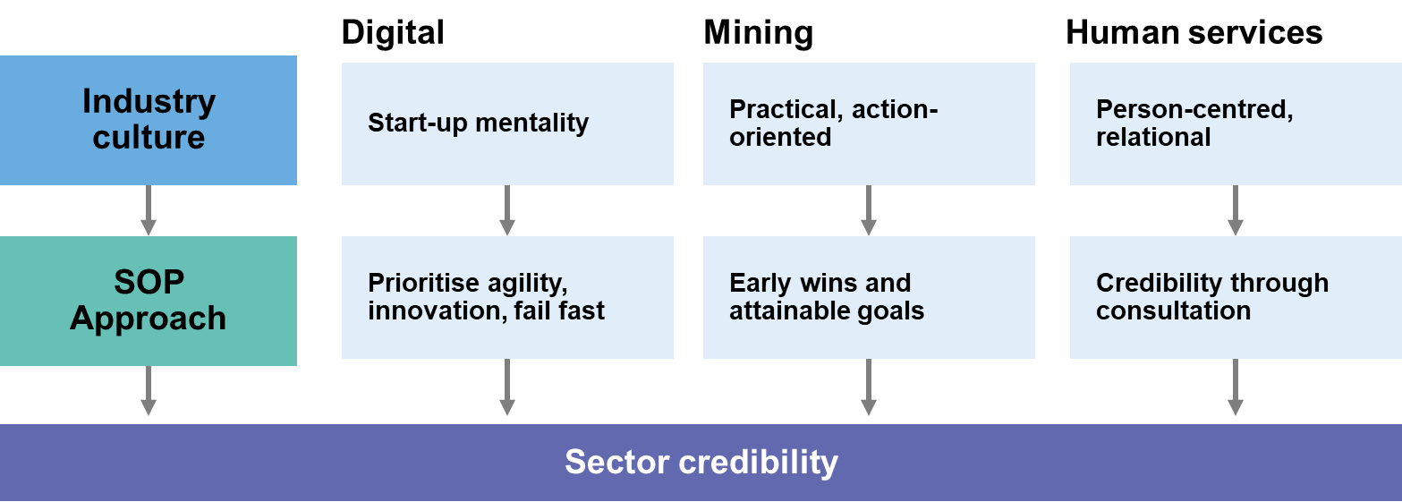

### Project delivery is generally through partnerships or contracted support

As discussed in Section 3.1, the SO Pilot program guidelines establish broad parameters for action by SO Pilots in determining priorities in the best interest of their industry, and Section 3.4 summarised the diversity of activities being undertaken. The approach to resourcing and delivering on these key activities for all SOs has been through a partnering model that extends core in-house capacity and capability by drawing on external organisations and contractors. The rationale for this approach lies in the need for SOs to be both agile in their configuration and efficient in the execution.

At this stage, pilot projects are mainly being delivered via a partnership model that enables SOs to access skillsets and organisational platforms from outside each SO. The emphasis on contracting or partnering in this way allows SOs to efficiently secure required resources for each particular project, without needing to attract, retain and manage a substantial and diverse workforce. This flexibility was afforded to the SOs under the contract arrangements and establishment by DESE.

Each SO remains relatively small, although there are plans to expand staffing levels at Human Services SO and Digital SO, while the future state for Mining SO was less clear at the time of writing. The Mining SO has a small staffing complement, and has partnered with or contracted external organisations to work collaboratively with the Mining SO on project delivery. For example, Mining SO partnered with the Meyvn Group (consultants), Rio Tinto, FMG, BHP, WesTrac, South Metropolitan TAFE and the WA Government for their Apprenticeships project (further details in Section 2.3).

The Human Services SO has recently expanded its core team, but also pursues partners to deliver its work program. For example, the Human Services SO has worked with PricewaterhouseCoopers Australia (PwC) to evaluate the ‘Entry into Care Roles’ skill set, through analysis of its delivery by the Brotherhood of St Laurence through an existing ‘transition to work’ trial for young people. The Human Services SO has also contracted the Community Services Industry Alliance (CSIA) to complete the Mapping the Sector project.

Digital SO are utilising both partnership-based and contracting models to access expertise and engage with stakeholders. They have partnered with Queensland TAFE, General Assembly and Goanna Solutions to deliver the Train100 pilot. This partnership will facilitate access to different cohorts of learners to test the pilot. Digital SO have commissioned the National Centre for Vocational Education Research (NCVER) to deliver a research report on digital pathways.

The next phase of this evaluation (Project 2) will explore in more depth the implementation of projects and activities by each SO, and capture the early impacts and lessons learned from these activities.

# Appendix A: Evaluation Framework

The Evaluation Framework has been built with reference to the *Pilot Skills Organisations: Draft Evaluation Framework* (2020) (The Deloitte Evaluation Plan) and aims to answer the three key evaluation questions defined for Project 1.

| **Key evaluation questions** | **Lines of inquiry** | **Data sources** |
| --- | --- | --- |
| How effectively has the Department ‘stood up’ the three Pilot SOs to position them for success? | * Nature and quality of support provided by the Department during establishment * Nature and quality of ongoing support, and contract and performance management throughout implementation * Impacts of Department’s establishment support on positioning SOs to succeed | * Interviews – The Department (VET Branch, NSC, NCI and ASQA) * Interviews – The Department (Pilot SO support staff) * Interviews – Staff from Pilot SOs * Pilot SO documentation |
| What progress have each of the Pilot SOs made in establishing themselves, identifying areas where they can make an impact, and implementing relevant activities? | * Nature and quality of organisational structures and planning, including Organisational strategy, Governance structures, Budgeting, Risk management planning, Quality assurance mechanisms * Level and appropriateness of staffing and resourcing (including number of staff and relevant skills) * Number and type of activities planned, underway and completed to date * Number and type of industry stakeholders engaged to date * Experience of industry stakeholders in engaging with Pilot SOs * Points of difference between the Pilot SOs * Collaboration between Pilot SOs to date | * Interviews – The Department (VET Branch, NSC, NCI and ASQA) * Interviews – The Department (Pilot SO support staff) * Interviews – Staff from Pilot SOs * Interviews – Other stakeholders * Pilot SO documentation |
| What opportunities are there to optimise the establishment of SOs (or similar models) and their implementation of relevant activities? | * Factors that have impacted establishment and implementation (barriers and enablers) * Opportunities for improvement | * Interviews – The Department (VET Branch, NSC, NCI and ASQA) * Interviews – The Department (Pilot SO support staff) * Interviews – Staff from Pilot SOs * Interviews – Other stakeholders * Pilot SO documentation |

# Appendix B: Stakeholders consulted

| **Name** | **Organisation** | **Role** |
| --- | --- | --- |
| **Government stakeholders** | | |
| 16 stakeholders | DESE | Various |
| Susan Bearfield | NSW Government | Manager of National and Reform for VET and Skills |
| Bec Curtain | SA Government | Director, Skills Policy Reform |
| Angela Hope | NSC | Assistant Secretary, Forecasting, Skills and Analysis Branch, NSC |
| Dr Ross Kelly | WA Government | Director Policy Planning and Research, Department of Training and Workforce Development |
| Saxon Rice | ASQA | CEO |
| Catherine White | NT Government | General Manager (Business & Workforce), Department of Industry, Tourism and Trade |
| Nelson Brown | NT Government | Policy Officer, Department of Industry, Tourism and Trade |
| **SO staff/consultants/project partners** | | |
| Yasmin Allen | Digital SO | Chairman |
| Lyndon Blanchard | Digital SO | Chief Operating Officer |
| Russell Bricknell | Baptistcare | Deputy Chair/CEO |
| Sally Browner | Goanna | CEO |
| Kasy Chambers | Anglicare Australia | Executive Director |
| Liz Cohen | Cara | Chief Executive |
| Tania Constable | MCA | CEO |
| Sarah Dart | ARC Disability Services | HR Manager |
| Michael Eichler | Anglicare Sydney | Learning and Leadership Development Manager |
| Angela Flierman | Avenir Consulting | Director |
| Jackie French | QLD TAFE | Director of Faculty, Creative Arts and Digital Design |
| Annissa Hansen | Human Services SO | Director, Program Management and Operations |
| Nigel Haywood | MCA | Senior Manager |
| Elmina Joldic | Brotherhood of St Laurence | Acting Head of Youth |
| Patrick Kidd | Digital SO | CEO |
| Gavin Lind | Mining SO | Project Lead and Working Group Chair |
| David Masters | Digital SO | Board Member |
| Rod MacDonald | Ithaca Group | Principal |
| Ryan Meyer | General Assembly | Managing Director, APAC |
| John Murray | RAAF | CEO |
| Geethani Nair | Digital SO | Director, Digital Skills and Concepts. |
| Ross Raeburn | Digital SO | Chief Marketing & Partnership Officer |
| Georgia Ryburn | PWC | Manager |
| Jodi Schmidt | Human Services SO | CEO |
| Karolina Szukalska | MCA | Manager – Education |
| Amanda Thomas | Human Services SO | General Manager |
| Simon Walker | NCVER | CEO |
| Claire Werner | Meyvn Group | CEO |
| Emily Wood | Human Services SO | Communications Specialist |
| Belinda | Human Services SO | Board Secretary |
| **VET/industry stakeholders** | | |
| Jodie Badcock | Resources and Engineering Skills Alliance (RESA) | CEO |
| Jodie Davis | Australian Nursing and Midwifery Federation (ANMF) | Chair – Direct Client Care and Support IRC |
| Sonia Di Menno | Rio Tinto | Strategy and Planning BP, Human Resources |
| Michelle Gibson | BHP | Head of Mastery and Training |
| Garry Gow | Australian Unity | Head of Operational Insight |
| Lyndal Groom | PM&C | Special Adviser, PM&C's Digital Technologies Taskforce |
| Andrew Jamieson | Benatas | Head of Talent & Capability |
| Ben Keast | ARC Disability Services | CEO, Chair - Disability Support IRC |
| Jenny Lambert | Australian Chamber of Commerce and Industry | Director, Employment, Education and Training |
| Megan Lilly | Australian Industry Group | Head of Workforce Development |
| Renae Lowry | Boosting Local Care Workforce Program (DSS Project) | Subject Matter Specialist |
| Jennifer Mulveny | Adobe | Director, Government Relations, Asia-Pacific |
| Louise O'Neill | ACWIC | CEO |
| Mike Pope | Business Council of Australia | Senior Policy Advisor |
| Marcus Riley | Ballycara | Executive Chairman; Chair Aged Care IRC |
| Craig Robertson | TAFE Directors Australia | CEO |
| Susan Scocroft | Community Services & Health ITA | Executive Director |
| Caroline Thompson | Community Services, Health & Education Training Council  Inc | Executive Director |
| Lee Veitch | Li-Ve | Manager - Workforce Planning and Development |
| Paul Walsh | SSO Australian Industry Standards | CEO |
| Troy Williams | Independent Tertiary Education Councils of Australia | CEO |
| Wenwen Ye | ThinkPlace | Senior Executive Designer |

# Appendix C: References cited

**References cited**

All hyperlinks last accessed 22/02/2022

Australian Bureau of Statistics. (2020). *Australian system of national accounts.* Retrieved from <https://www.abs.gov.au/statistics/economy/national-accounts/australian-system-national-accounts/2019-20>

Australian Bureau of Statistics. (2020, October). *Australian system of national accounts.* Retrieved from <https://www.abs.gov.au/statistics/economy/national-accounts/australian-system-national-accounts/latest-release>

Australian Government Department of Health. (2020). *A matter of care: Australia's aged care workforce strategy*. Retrieved from <https://www.health.gov.au/resources/publications/a-matter-of-care-australias-aged-care-workforce-strategy>

Australian Government Department of Industry, Science, Energy and Resources. (2021). *Australia's national resources workforce strategy.* Retrieved from <https://www.industry.gov.au/sites/default/files/2021-02/australias_national_resources_workforce_strategy.pdf>

Australian Government Department of Prime Minister and Cabinet. (2019). *The digital technology taskforce.* Retrieved from <https://www.pmc.gov.au/domestic-policy/digital-technology-taskforce#:~:text=The%20Taskforce%2C%20hosted%20in%20the,released%20Australia's%20Digital%20Economy%20Strategy>

Australian Government. (2019). *Budget 2019-20.* Retrieved from <https://archive.budget.gov.au/2019-20/>

Australian Public Service Commission (2021). *Understand your authorising environment.* Retrieved from <https://www.apsc.gov.au/initiatives-and-programs/workforce-information/taskforce-toolkit/governance/understand-your-authorising-environment>

Deloitte Access Economics. (2021). *Economic contribution of the mining and METS sector.* Retrieved from <https://www.minerals.org.au/sites/default/files/DAE%20-%20Contribution%20of%20Australian%20mining%20&%20METS%202019-20.pdf>

Department of Education, Skills and Employment. (2020). *About skills organisations.* Retrieved from <https://www.dese.gov.au/skills-organisations>

Department of Education, Skills and Employment. (2020). *Guidelines for skills organisation pilots*. Retrieved from <https://www.dese.gov.au/skills-organisations/resources/guidelines-skills-organisations-pilots>

Department of Education, Skills and Employment. (2020). *'This is what we heard'.* Retrieved from <https://www.dese.gov.au/skills-organisations/resources/so-what-we-heard>

Department of Education, Skills and Employment. (2021). *Skills organisations update - 1 March 2021.* Retrieved from <https://www.dese.gov.au/skills-organisations/fact-sheets/skills-organisations-update-1-march-2021>

Department of Prime Minister and Cabinet. (2021). *Digital economy strategy 2030.* Retrieved from <https://digitaleconomy.pmc.gov.au/sites/default/files/2021-07/digital-economy-strategy.pdf>

Digital Technology Skills Organisations Pilot Steering Group and Working Group Terms of Reference. (2020). *Digital Technology Communique*. Retrieved from <https://www.dese.gov.au/skills-organisations/digital-skills-organisation-pilot/digital-technology-communiques>

Digital Technology Skills Organisations Pilot Steering Group and Working Group Terms of Reference. (2020). *Digital technology skills and terms of reference.* Retrieved from <https://www.dese.gov.au/skills-organisations/resources/digital-technology-skills-organisation-pilot-terms-reference>

Glaser, B., & Strauss, A. (2009). *Better evaluation.* Retrieved from <https://www.betterevaluation.org/en/search/site/grounded%20theory>

Human Services SO. (2020) *Human service skills organisation limited communications and stakeholder engagement strategy.* Retrieved from <https://hsso.org.au/>

Innovation and Science Australia. (2017). *Australia 2030: prosperity through innovation.* Retrieved from <https://www.industry.gov.au/sites/default/files/May%202018/document/pdf/australia-2030-prosperity-through-innovation-full-report.pdf?acsf_files_redirect>

Joyce, S. (2019). *Strengthening skills: expert review of Australia's vocational education and training system.* Retrieved from <https://www.pmc.gov.au/resource-centre/domestic-policy/vet-review/strengthening-skills-expert-review-australias-vocational-education-and-training-system>

Labour Market Information Portal. (2021). *Health care and social assistance.* Retrieved from <https://lmip.gov.au/default.aspx?LMIP/GainInsights/IndustryInformation/HealthCareandSocialAssistance#:~:text=Health%20Care%20and%20Social%20Assistance%20employs%20approximately%201%2C832%2C300%20persons%20(ABS,increased%20by%2017.1%20per%20cent>

Labour Market information Portal. (2021). *Mining*. Retrieved from <https://lmip.gov.au/default.aspx?LMIP/GainInsights/IndustryInformation/Mining#:~:text=Mining%20employs%20approximately%20252%2C100%20persons,increased%20by%2015.7%20per%20cent>

Minerals Council of Australia. (2021). *MCA membership.* Retrieved from <https://www.minerals.org.au/mca-membership>

National Skills Commission. (2021). *Care workforce labour market study: discussion paper.* (Research Discussion Paper RDP 2021). Retrieved from National Skills Commission website: <https://www.nationalskillscommission.gov.au/discussion-paper-care-workforce-labour-market-study>

Organisation for Economic Co-operation and Development. *(Eds.) (*2018). J*ob creation and local economic development 2018: preparing for the future of work.* Retrieved from <https://www.oecd.org/cfe/leed/LEED-Flagship-Policy-Highlights.pdf>

World Bank. (2019). *World Development report 2019: the changing nature of work.* Retrieved from <https://www.worldbank.org/en/publication/wdr2019>



**Disclaimer**

This report is dated August 2021 and incorporates information and events up to that date only and excludes any information arising, or event occurring, after that date which may affect the validity of Urbis Pty Ltd and ARTD Pty Ltd **(Urbis and ARTD)** opinion in this report. Urbis and ARTD prepared this report on the instructions, and for the benefit only, of the Department of Education, Skills and Employment **(Instructing Party)** for the purpose of evaluating the Skills Organisations Pilot **(Purpose)** and not for any other purpose or use. To the extent permitted by applicable law, Urbis and ARTD expressly disclaim all liability, whether direct or indirect, to the Instructing Party which relies or purports to rely on this report for any purpose other than the Purpose, and to any other person which relies or purports to rely on this report for any purpose whatsoever (including the Purpose). In preparing this report, Urbis and ARTD were required to make judgements which may be affected by unforeseen future events, the likelihood and effects of which are not capable of precise assessment. All surveys, forecasts, projections and recommendations contained in or associated with this report are made in good faith and on the basis of information supplied to Urbis and ARTD at the date of this report, and upon which Urbis and ARTD relied. Whilst Urbis and ARTD have made all reasonable inquiries it believes necessary in preparing this report, we are not responsible for determining the completeness or accuracy of information provided to it. Urbis and ARTD (including our officers and personnel) are not liable for any errors or omissions, including in information provided by the Instructing Party or another person or upon which Urbis and ARTD relies, provided that such errors or omissions are not made by Urbis and ARTD recklessly or in bad faith. This report has been prepared with due care and diligence by Urbis and ARTD and the statements and opinions given by Urbis and ARTD in this report are given in good faith and in the reasonable belief that they are correct and not misleading, subject to the limitations above.



1. Department of Education, Skills and Employment [DESE] (2020). *Guidelines for skills organisation pilots.*
2. DESE (2020). *Guidelines for skills organisations pilots*, p5.
3. DESE (2020). *Guidelines for skills organisations*, p5.
4. Ibid, pp12-13.
5. Ibid, pp4-5.
6. Ibid, pp4-5.
7. Australian Bureau of Statistics [ABS] (2020). *Australian system of national accounts*. Retrieved from <https://www.abs.gov.au/statistics/economy/national-accounts/australian-system-national-accounts/latest-release>
8. World Bank (2019). *World development report 2019: The changing nature of work*.
9. Organisation for Economic Co-operation and Development [OECD] (2018). *Job creation and local economic development 2018: preparing for the future of work*.
10. Innovation and Science Australia (2017). *Australia 2030: prosperity through innovation*.
11. National Skills Commission (2021). *Care workforce labour market study: discussion paper*.
12. Joyce (2019). *Strengthening skills: expert review of Australia’s vocational education and training system*.
13. DESE (2020). *Guidelines for skills organisation pilots*.
14. Joyce (2019). *Strengthening skills: expert review of Australia’s vocational education and training system*.
15. Australian Government (2019). *Budget 2019-20*.
16. Ibid.
17. DESE (2019). *Skills organisations national co-design workshops discussion paper*.
18. DESE (2020). *‘This is what we heard’*.
19. Ibid.
20. Ibid.
21. Ibid.
22. DESE (2020). *Guidelines for skills organisations, p 16.*
23. DESE (2020). *About skills organisations.*
24. Glaser & Strauss (2009). *Better evaluation.* Retrieved from <https://www.betterevaluation.org/en/search/site/grounded%20theory>
25. Labour Market Information Portal (2021). *Health care and social assistance.* Retrieved from <https://lmip.gov.au/default.aspx?LMIP/GainInsights/IndustryInformation/HealthCareandSocialAssistance#:~:text=Health%20Care%20and%20Social%20Assistance%20employs%20approximately%201%2C832%2C300%20persons%20(ABS,increased%20by%2017.1%20per%20cent>.
26. Human Services SO (2020). *Human services skills organisation limited communications and stakeholder engagement strategy.*
27. Australian Government Department of Prime Minister and Cabinet [DPM&C] (2019). *The digital technology taskforce.* Retrieved from[Digital Technology Taskforce | Department of the Prime Minister and Cabinet (pmc.gov.au)](https://pmc.gov.au/domestic-policy/digital-technology-taskforce#:~:text=The%20Digital%20Economy%20Strategy%20sets,to%202030%2C%20including%20ambitious%20targets.)
28. Joyce (2019). *Strengthening skills: expert review of Australia’s vocational education and training system*.
29. Digital Technology Skills Organisation Pilot Steering Group and Working Group Terms of Reference (2020). *Digital technology communiques.* Retrieved from: <https://www.dese.gov.au/skills-organisations/digital-skills-organisation-pilot/digital-technology-communiques>
30. Digital Technology Skills Organisation Pilot Steering Group and Working Group Terms of Reference (2020). *Digital technology skills and terms of reference*. Retrieved from <https://www.dese.gov.au/skills-organisations/resources/digital-technology-skills-organisation-pilot-terms-reference>
31. Labour Market Information Portal (2021). *Mining*. Retrieved from <https://lmip.gov.au/default.aspx?LMIP/GainInsights/IndustryInformation/Mining#:~:text=Mining%20employs%20approximately%20252%2C100%20persons,increased%20by%2015.7%20per%20cent>.
32. ABS (2020). *Australian system of national accounts*. Retrieved from <https://www.abs.gov.au/statistics/economy/national-accounts/australian-system-national-accounts/2019-20>
33. Deloitte Access Economics (2021). *Economic contribution of the mining and METS sector*. Retrieved from <http://minerals.org.au/sites/default/files/DAE%20-%20Contribution%20of%20Australian%20mining%20%26%20METS%202019-20.pdf>
34. MCA (2020). *Mining SO interim governance structure terms of reference*.
35. DESE (2021). *Skills organisations update – 1 March 2021*.
36. DESE (2020). *Guidelines for skills organisations pilots*, p5.
37. Australian Public Service Commission (2021). *Understand your authorising environment*. Retrieved from <https://www.apsc.gov.au/initiatives-and-programs/workforce-information/taskforce-toolkit/governance/understand-your-authorising-environment>
38. The IRCs are the representative groups responsible for ensuring training package development considers industry skills requirements. The SSOs support the IRCs offering secretariat support and assisting training package development.
39. On 28 October 2021, the Australian Government announced $292.5 million to establish the new Industry Clusters model to replace SSOs and IRCs, which are expected to be fully operational by 1 January 2023.
40. Australian Government Department of Health (2020). *A matter of care: Australia’s aged care workforce strategy.*
41. This is one of the core qualifications for workers in the community and/or residential setting who provide person-centred support to people who require support due to ageing, disability or some other reason.
42. Australian Government Department of Industry, Science, Energy and Resources (2021). *Australia's national resources workforce strategy.*
43. DPMC (2021). *Digital economy strategy 2030.*
44. DESE (2020). *Guidelines for skills organisations pilots*, p5.
45. Ibid, pp12-13.
46. Minerals Council of Australia (2021). *MCA membership*. Retrieved from <https://www.minerals.org.au/mca-membership>
47. We heard that while the Australian Government regulates and funds many human service sectors, access to sector-wide stakeholder contact information to support coordinated communication has proven challenging.
48. Human Services SO (2021). *Communication and engagement strategy and implementation plan*, p.4.
49. Digital SO (2020). *Digital SO engagement strategy*, p.6.
50. We note that Mining SO has invited TAFE Directors Australia to be an observer to its steering committee, but the shape of their future board is not yet known.
51. DESE (2020). *Guidelines for skills organisations pilots*, p16.
52. Ibid, pp4-5.
53. Ibid, p4.